Analysis

# Proposed solution

In this project I will attempt to make a model of the spread of different viruses which can infect multiple computers. My project will take place in the UK with 4 key locations; London, Edinburgh, Cardiff and Norwich. These cover some of the main areas in the UK because they are each located in the north, south, east and west. I will be attempting to show a virus called the worm this infects your computer with malware and then sends an email to all of your contacts which in turn installs there computers with malware ext. the main purpose for my project is to show the effectiveness of some viruses.

# Described and justified the features that make the problem solvable by computational methods, explaining why it is amenable to a computational approach.

‘Computational thinking involves solving problems, designing systems, and understanding human behaviour, by drawing on the concepts fundamental to computer science’ the five ways that a problem could be computation is by; Thinking Abstraction, thinking concurrently, thinking logically, thinking ahead and thinking procedurally. This means that for my project to be solved by computational methods it needs to involve one of the methods above.

My project is a simulation if modern day society was infected by computer virus. This would be represented by each day going by and calculating the infection rate then deduct the amount of computers that stop the malware using anti-virus to determine the amount of computers infected.

One of the key aspects of my project is abstraction. Abstraction means to show a complex system in a basic visual view removing unnecessary information. My project takes place in the UK this means that part of my abstraction will remove roads and other geographical icons. Instead it will contain 4 main cities, London, Edinburg, Cardiff and Norwich. I will also use red dots to represent the amount of computers in the 10’s of thousands.

The main aspect of my project is logic; this is because logic deals with a logical step by step approach to solving complex problems. The number of procedure that I am aware of that I will be using per virus is; the overall amount of infected computers, the amount of computers that are potentially vulnerable in the given day, the amount of computers that are safe due to anti-virus software, the overall amount of computers that were infected in the day and one unique aspect for each virus. There are only 5 modules in my project, these are; open screen, menu, worm, malware and browser hijacker.

The project will include multiple modules, my first module would be the home page this will be a rough introduction with a title and three buttons; help, next page and close. The help button will display some text explaining how to navigate the pages explaining that to go to the menu you have to click the next page button and the close button will close the program. The close button will close the program. The next page button will link the open page to the menu page where you can select the type of virus you want to do. The next module will be the menu on this page there will be a title and three buttons each giving a rough description of each virus’s unique characteristics each button will have the name of the relevant virus and possible a type of picture to represent the virus. There will also be a back button which will bring you back to the last page. One each of the viruses’ page it will load you onto a page and some user input text boxes will come up asking for relevant information relating to the virus. When all of them are done the map will be shown, there will be one dot on one of the cities which will indicate that there is one infected computer.

## Identified suitable stakeholders for the project and described them explaining how they will make use of the proposed solution and why it is appropriate to their needs.

I will have 2 stakeholders, my first stake holder is a computing teacher named Miss Fowler. Within the classroom there will be multiple users, for my project I will have a class of GCSE students studying computer science. A second potential stakeholder a cyber security firm, There users will be clients depending on the type of clients they protect. To determine how the teacher will use my simulation I will create a questionnaire asking her several questions. My first questionnaire’s results told me that she will mainly using it for her GCSE students this is because there is a unit for cyber security this means they have to have an understanding of malware, phishing, bruit force attacks and SQL Injection this means that my program will illustrate how effective they can be and then show how they can reduce the effectiveness of them. In our school we participate in a national competition called ‘cyber centurion’, she was thinking that she could use it as an introduction into it this. Cyber centurion is designed for all years but miss fowler did say that it would most likely be used for year 8 students. Miss fowler said that she would like it so that she could just keep it in the background so that she could start it at the beginning of the lesson and see how it would advance to the end of the lesson.

My second questionnaire’s results told me that the manager of a cyber security firm wouldn’t use it to show to her employees this is because they should already have knowledge of cyber security however she may use it for new employees. She did however say that it would be beneficial for some of new clients to give them an understanding of what cyber security is and the effect that a cyber-attack could have. She also said that it would be beneficial to go on their website to get new clients. When I asked her whether she would want a menu system or one after another system to navigate between viruses she said that a menu system would be better.

## Researched the problem in depth looking at existing solutions to similar problems, identifying and justifying suitable approaches based on this research

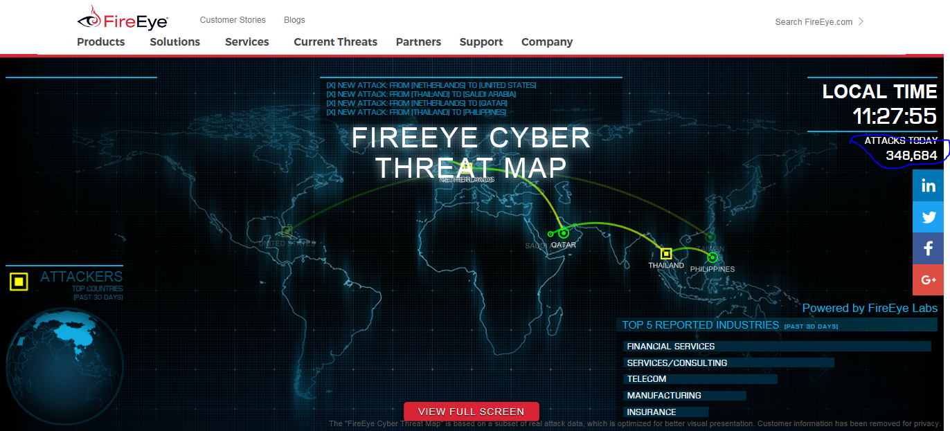

FireEye cyber threat map is a graphical representation of live cyber-attacks between countries. This is used for both fun and to show the amount of attacks which can help year 9 student understand the need for cyber security. Some features of this program are the map which is fixed screen (no zooming in or out) this means that the whole world can’t be to scale but it means that you can see all threats at once. There is also a rotating earth in the bottom left hand corner. There is also a terminal at the top witch shows the most recent attacks within the last couple of seconds. One of the better features in my option is the active count of threats in that day.

Features that I would use;

* Active threat count  
  I think that this is a feature in most of the research that I have done which means that it would be good to use.
* Fixed map  
  this feature means that you can see all different attacks that is going on at the moment which could be useful.
* General statistics  
  this tells the use different information which will be useful for my second stake holder (cyber security manager)

Features that I won’t use:

* The rotating world  
  this isn’t necessary because my simulation will be for UK which means that it won’t be in 3 dimensions. Also due to this being coded in Java it means that I will not be able to do 3d models.

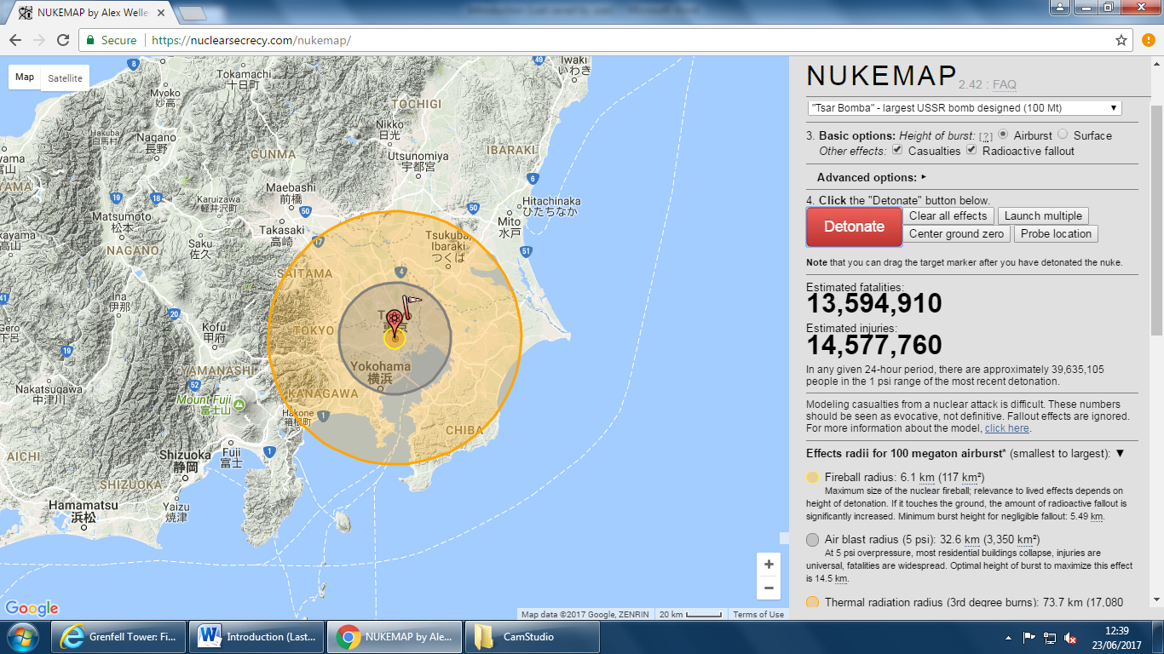

Nuke map is a simulation that is on the internet for free where it simulated different scenarios depending on a variety of inputs made by the user as shown on screen. One of the main things that is good about this system is that it has an interactive map as shown above, when a nuke is dropped it will display three rings a light yellow a grey and a light yellow these each represent different things, the light yellow is the fire ball from the nuke this is determined by the yield of the bomb. The grey outline is the wind blast which will demolish most buildings. And the final ring shows the radiation fall out this means that this area will have 3rd degree burns and sever radiation which will make the land useless for plant growth. One of the features that are in this simulation is the death and injured count this goes up as more people die. This feature is very interactive because it increments instead of jumping to an end result. Another feature that is good for this application is that it gives a variety of effects such as whether or not it is an Airburst or Surface. Airburst means that the bomb will explode above the ground this means that the grey (wind damage) will be much bigger meaning more deaths however the light yellow ring(radiation fall out) will be smaller reducing the amount injured. Another feature is whether or not you want to display the nuclear fallout or the death count and just show the blast zone this is a good feature because you can customize the program for the client’s needs.

Some features that I want in the program

* Customable features

I think this feature will help accommodate for my very different stake holders being to make it more or less interactive depending on the age that they are using it for.

* End results  
  this shows the amount of damage that is done at the end before exiting I will however be offering to show how effective it live while in game instead of at the end.
* Display of deaths and injured

This feature where the program makes the count goes up in increments make suspense to see how well the bomb did, or in my case the virus did. One difference is that I will be showing infected computers rather than number of dead people.

Features that I will not be using

* Linked to google maps

Due to my time restraint I will only be able to show my simulation on the UK, this means that there is no need to link to google maps.

* No fixed locations

My simulation you will be able to select one of 4 different places to start so you will not be able to put it anywhere.

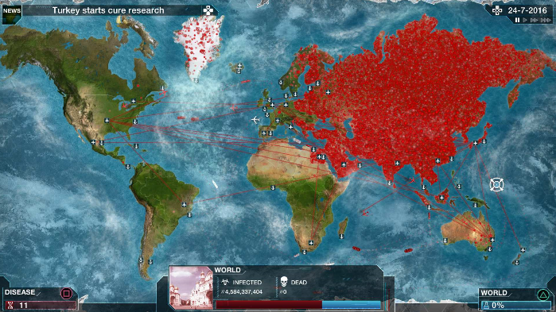

Plague Inc. is a strategy simulation for iOS and android, in this game you take control of a virus where your goal is to kill the whole world, using the virus. Some of the features that this game has is that it has; an interactive map this means that when you click on a country it gives you information about the country it also displays the amount that is infected and dead in the view, also the map displays red dots depending on the amount of infected people in that location and black dots for the amount that is dead this data is also shown in the tab at the bottom which give you the exact number rather than the looking at the map to tell, it also includes an upgrade section where you can customise your virus to give it different attributes which will cost DNA points in turn these features increase one of three characteristics infectivity, severity and lethality . infectivity means how quickly the virus will spread within a country and with upgrading the different features in the infectivity tab this will increase the infectivity for different things such as spreading internally inside a country or spread air/water born so you can infect boats and planes to go between countries. The severity will determine how well known you are, if you are too well known then the cure bar will start to increase when the bar is full you lose and the game is over. The lethality section will increase how likely you are too kill someone depending on how much DNA points you spend on the lethality tab will determine how many people will day per day, however if loads of people are dying then the severity will go up this means that you need to kill everyone very quickly or else you will be cured. There are also many different viruses that you unlock as you play more throughout the game, you select a virus through the menu in the starting page. There are also different difficulties which will increase the chance of you being discovered and increase the cure rate however you get special effects which you will unlock if you win the game at different difficulties.

Some of the features that I think would be good to use for my project would be

* The interactive map  
  I think that this would be a good idea for my project because you could use the different colours to show the infected computers and the broken computers. The difference between plaque’s Inc. maps is that I would only represent the UK instead of the world also the red and black dots would be localised to specific cities.
* Statistic of infectivity  
  in my project I think it would be good to show the number of infected computers and then do percentages of that to show how much left you have to infect

Some features I won’t be using

* The interactivity

The ability to change your virus to make it better in active gameplay, this is because I find it to be to unrealistic and my program if for legitimate use, however I might give pop ups to help the year 9 students more engaging.

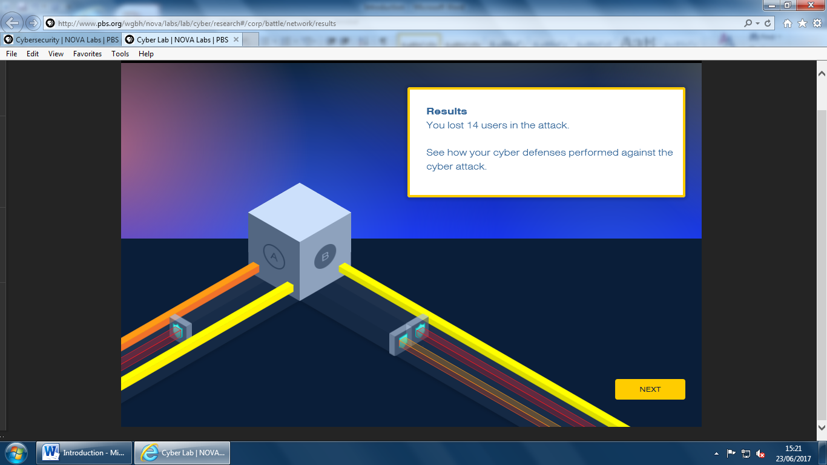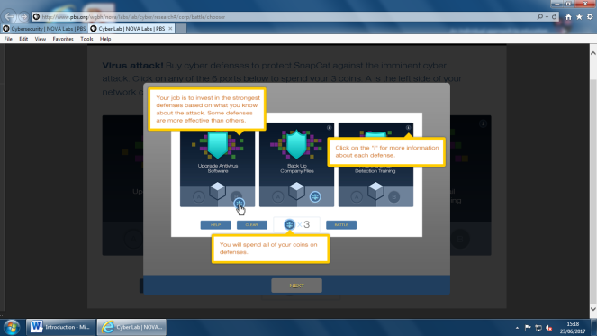

Nova labs are an interactive educational game where your objective is to get users back from cyber-attacks. To get users back you have to play educational games. By doing these challenges it teaches year 9 students how to protect themselves on the internet while also reinforcing coding from school. I know this because to help me learn leadership skills.

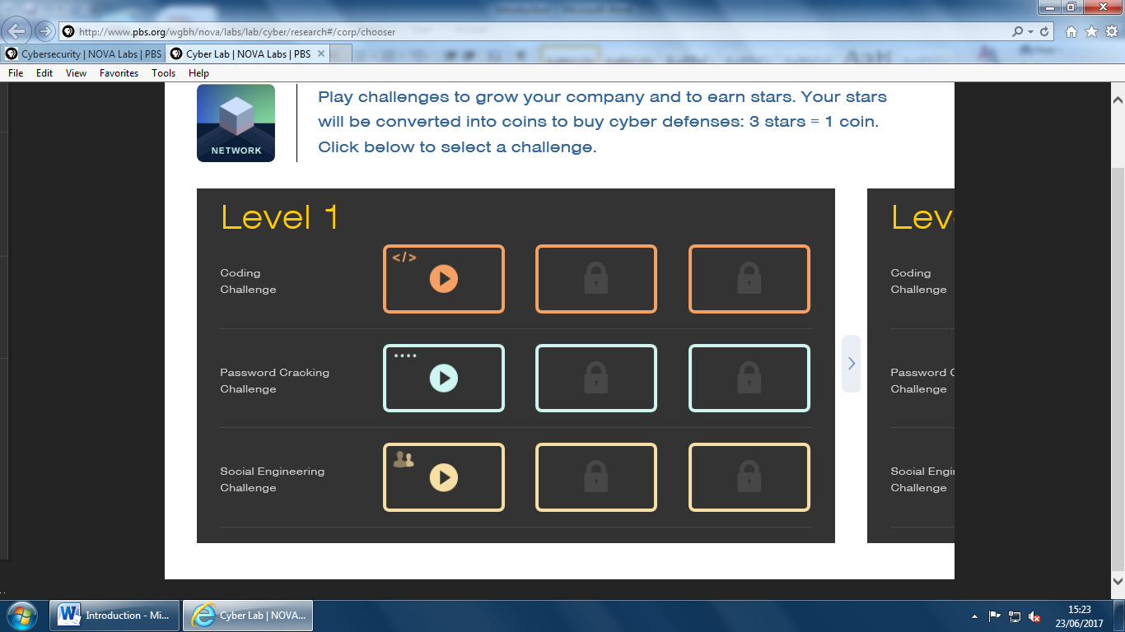

This is the main menu where you can navigate between challenges to progress through the mail story.

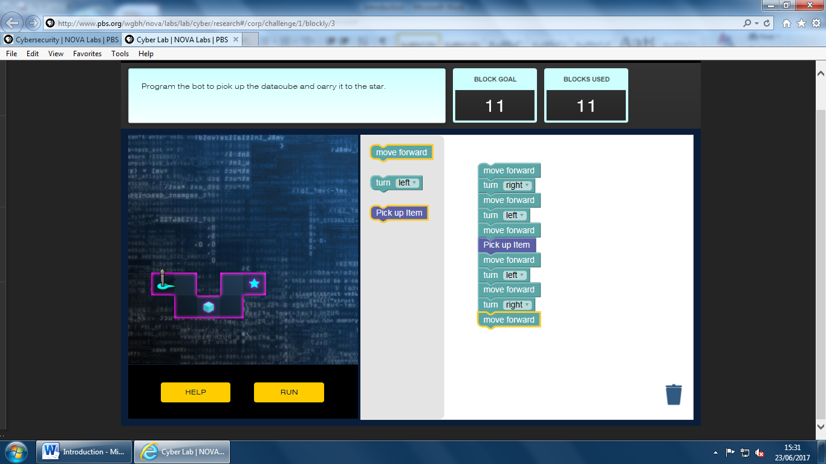

This is the coding challenge where you navigate a character through a set of challenges to reach the end

There is also password cracking where the objective to make a secure password to prevent people from attacking you, it is also recommended to make it as long as possible with a variety of symbols letters and capitals to make hacking it harder. The next section is to hack into someone who hasn’t made a good password by guessing common passwords such as ‘password’ or other such common passwords. The next section is to use the brute force method where you put in the parameters such as password length and whether or not try characters when guessing the password. This system works by guessing every possibility until it enters you in. this is a good way of showing how to protect yourself when making passwords.

The next section is to use social engineering (phishing) this means identifying differences between the two emails to determine which is fake such things can include not including capitals or coming from an unknown email address. This will protect people from phishing which is very dangerous because it causes people to enter in there passwords which will grant access to the hacker to your accounts.

Some features that I will use are;

* Menu  
  I will use the menu to navigate between simulations
* User friendly  
  my program will be designed to be appealing to the eye to help engage the younger years which one of my stake holders will be using it for. It will also make it professional so it doesn’t look tacky.
* Educational  
  my program will help to show the principals of cyber security to help enhance the learning of the GCSE students.

## Summary

Some of the common features between the first three examples all include a map however they represent them in different ways I would use a still image which you can click on for more information like the ‘fire eye threat map’. Another key thing which is included in the first three projects is a kill/threat count which shows the progress of your virus/bomb. Another key feature between all of the resources is that they are very bright; this means that they have engaging colour design which helps to engage the audience. I will try to do this by making the colour design correct my stakeholder’s specification some colours may include red, orange, blue and grey these may be used to represent different things as shown in the NUKEMAP simulation where the circles are colour coded. My last example included an educational feature this is done by playing different games to help reinforce what they learned in school. They also did different progressions each being harder than before which I will show by doing a dial to increase the cyber security rating, this will be done so that it can show how well we need to increase cyber security to help combat this problem. When doing research into algorithms to determine the spread of a virus, there was very little this means that I will probably use my own set of rules to show a rough representation of what this can do and not the actual amount that would be infected. I will also have to do the same for the cyber security rating rather than showing a very realistic model.

# Identified the essential features of the proposed computational solution explaining these choices

|  |  |  |
| --- | --- | --- |
| No. | features | Explanation |
| 1 | Colour scheme, I will make all of the pages fit a specific colour scheme, there will be three colours. Colour 1 will be a light colour. Colour 2 will be light. Colour 3 will be a bright colour with contrast to colour 2. Colour 1 will be used as a background colour for all of my pages. Colour 2 is the any activator such as a button or a diel. Colour 3 will be a representing colour this be used to help show the amount of infected computers. Colour 1 is a light green. Colour 2 is a light blue and colour 3 will be bright red. | My reasoning for having a colour scheme is that it should help to keep people interested in my simulation without getting too bored. My colour scheme will have to be decided between me and the client to help soot my project to their need. Colour 1’s colour will be dull this will help to make all the other colours stand out more. Colour 1 and 2 need to both be bright to help make year 9 students be drawn in by it. The reason why they need to be contrasting is because it is more appealing to the eye so you can see both of them easily. |
| 2 | Educational, my program will give the option beforehand whether or not you want to have informational pop ups. You can activate or disable them with a tick box which will decide change the module in the next 3 pages depending on what you click. If it is clicked every time a new amount of computers are infected it will tell you facts such as ‘if you want to protect your self don’t open emails you don’t know who they are from’. | The reason why I will give the option for whether or not you want the pop ups is because for my second stake holder the cyber security manager won’t want to learn about these things due to him already knowing this stuff and it can be very distracting. However I will give the option because it will help to teach year 9 students how to protect themselves online which is part of their curriculum, which my program will help to reinforce. |
| 3 | Interactive map, my map to show the spread of the virus in a visual way will have many useful features. The first feature is that it will show the spread of the virus by showing each 1thousand infected computers by 1 red dot this will increase as more computers are infected. Another function will be an infected computer count which will show how many you infected today, how many on computers on average you are infecting every day, how long it will take to infect the country at this average rate, how many computers are left to be infected and how many you have infected overall. Another features that my map will have is by clicking on a city on the map will show you how many you have infected in that city and how many are left to be infected. | The reason why I will have an interactive map is because it will help to analyse the situation for my second stake holder (cyber security manager) another reason why it would be useful to have an interactive map is because it will keep year 9 student interested. I will have to use the 1:1000 scale because it will mean that the screen doesn’t get overwhelmed. The reason why I will show all these statistics is because it will show points of failure in the system which can be reinforced. |
| 4 | Menu, I will have a menu in my program it will have 4 buttons each coloured in colour 2. The first button will be a back button which will take the program to the home screen. The next three buttons will each take you to the respective simulation relevant to the buttons. There will also be some text next to each of the buttons explaining what each of the viruses do. | The main reason for the menu system is that it will help to make the program both make it easy to navigate and will also make it user friendly. My stake holder said that it would be good for her this is because she would want to show specific examples instead of having to cycle through the other two virus simulations to reach the one she wants. |

## Identified and explained with justification any limitations of the proposed solution.

Due me designing my project by myself and with limited time and resources there are going to be some limitations in my project.

One of the main limiting factor when making this project will be the limited time, this will mean that I will have to limit my program to just the UK because programing individual specifications for each major location will be incredibly time consuming, due to their 196 countries each with several cities and towns. This would make it next to impossible in under a year. Another thing that I will have to limit due to time will be the amount of cites in the UK, as such I have limited it to 4, just to prove the concept works.

Another key limitation will be the algorithm, due to there not being an incredibly accurate model for the spread of a virus I will need to construct a rough algorithm to make the program reasonably accurate. I will make my own algorithms for each of the viruses by make a formula to track progress.

## Specified and justified the requirements for the solution including any hardware and software requirements.

For the current version of Greenfoot to work it will need to be run on a device, it will need to be ether; windows 7/8/10, mac 10.8.3 or later, Ubuntu or Debian, OS will require JKD or can be run from a USB which has JKD. They will all need to have the latest version of Java for my program to work this is because Greenfoot is a front end to Java. You will also need the latest version of adobe flash player. There is no way that you can run my simulation this means that the school would need to have java pre-installed for it to work, this is not a problem however because java is a key feature in computer science. The cyber security firm will be slightly harder however I can run it of a USB with JKD installed. There is very little hardware requirements this is because Java doesn’t take much memory meaning that you can have very low specs. This is defiantly not a problem because any school with a computer science programme will have good enough computers to run java and a cyber security firm will need good computers to do their job so it will be more than powerful enough to run java.

## Identified and justified measurable success criteria for the proposed solution.

From both my research into existing problems and the questionnaire that I asked my two stakeholders I have made a list of key criteria for my program to meet;

1. It will need to be user friendly. This means that I will put a help button on the starting page this is to help the user navigate between pages with ease. I will also try to make every page accessible using buttons I will also make all the pages look astatically pleasing. I will know if my program is user friendly if when I have finished the project 95% of people say it is user friendly.
2. It should also be easy to navigate. I will ensure this by making every button clear where it leads by using text. I will also make it so that every page is easy to get to by making each page can go back to the menu where you can then go to any page on the project. I will know if it is easy to navigate if 95% of the beta testers say it is easy to navigate.
3. My program will be astatically pleasing. I will make all pages fit a specific colour scheme this will include 3 main colours. The first colour will be a light grey and this colour will be used for the backgrounds. The second colour will be green; this is for buttons or for activators (such as the main cities). The last colour will be red; this is for the spread of the virus transmission paths.
4. All of the values when entering to define the virus will have multiple validation skills applied to it. The first type of validation will be data type validation, this will ensure that when I type in ‘one’ instead of ‘1’ instead of it making an error it will instead ask for them to re-enter it. The next type of validation will be range validation; this means that if the field will need to be between 1 to 10 if -1 was entered it will ask the user to enter a valid response. I will know if this is met if when doing alpha testing there is no errors when I enter an abnormal data.
5. The main page will have two buttons, the first button will lead onto the menu page and the next button will give some help on how to get between pages. The reason for the first button is to give access to the next page for the selection of the virus. The help button is to make the program more user friendly. The way I will know that this criteria is met is when the stating page module is finished and I am doing my alpha testing and there are both of the buttons are there are functional.
6. My program will include a help button and it will help people navigate my program. This reason why the information on the help button needs to be useful is that if the information is useless then it will make the button redundant. I will know if the information is useful by when doing beta testing for this module and I asked them if it was useful and 95% of them said yes then I know the button is valid.
7. I will also have 4 buttons on the menu page each leading to ether one of the simulations or leading back to the starting page. The reason for this is to give access to all the pages this will be useful for easy navigation around the project each button will have text telling what they lead to. I will know if it was successful if all buttons are functional and well labelled this will be determined by when doing beta testing 95% of people who was involved in the test said it was easy to navigate.
8. There will be a small description on how the virus spread and a description when it happened and other facts about the virus. This will be useful because it will help year 9 students study for their exam about the cyber security perfection and how useful cyber security is. I will know if this is successful if there is a description next to each button. I will find out if it is useful by my beta testers say it is good, I will want a minimum of 95% of the users say it was useful.
9. There will be a page between goings to the simulation asking for some mandatory information to make the simulation work such as amount of computers in UK there will also be a default option if needed. I will know that this is a success if when doing alpha testing the page works with all validation (listed on number 4) and will save the information for the next page.
10. On the simulation page there will be a number in the top right hand corner which says the amount of infected computers as well as other information such as on average computers infected every day, how long it will take to infect the UK at this average so far, how many infected computers overall and how many computers are left. I will know if this was successful if all the data was there and correct.
11. There will also be a button which will take you back to the menu. The reason for this button is if you change your mind and you want to go back to the main menu, it will also make the program easy to navigate. I will know if this has worked if there is a button and it is functional and able to make you go between pages.
12. There will also be red dots per infected computers. The ratio to dots per computer is 1 dot for every 1000 computers infected. This can be changed in the information in the input stage before going onto the map. The red dots will be localised to the correct city. I will know if this has worked if there are red dots being shown on screen and they are to the right ratio. I will also know if it has worked if they are being spawned in the correct location.
13. A sound will play when a button is pressed. This is to make the game more user friendly by making it more engaging. This will keep my year 9 users engaged preventing them from not learning.
14. A sound will play when a new goal is achieved on the infected counter. This will make the game also more engaging because it will make the year 9 students more engaged. The scale will be every 1000, so when there are 1000 computers infected it will play a sound, and then when they reach 2000 it will play a sound and so on.
15. The game must do correct calculation for the statistics table. If the statistics are wrong due to the calculations being wrong this would make my program not work because the cyber security company will not be able to use it as good evidence for their clients.

## Test plan key

Quantitative

Qualitative

## Test plan

|  |  |  |
| --- | --- | --- |
| No. test | User requirement | How I am going to test this |
| 1 | Does the program work on different monitor types. | I will know that this user requirement has been met if I change the resolution of the monitor and to see if the program is consistent between all different resolutions. |
| 2 | All the buttons must be the same colour and dimensions as one another on every page | I will know that this user requirement has been met by looking at the guy for each button and checking both the relative coordinates on the page, this will mean that all back buttons for example will be in the same corner, and the dimensions of the button this will tell me if the buttons are consistent. The way I know the colour will be consistent is by checking the hexadecimal value of the colour of the button this will ensure the colour is always the same |
| 3 | On the input page the spread input box must have a suitable input. | To test this I will put in normal, abnormal and border line data. An example of normal data would be 1 or 7 this is because the input box can only accept numbers. An example of abnormal data is the word ‘two’. The way I will checked for borderline data is first by entering in 1 and 100 this was to check to see if the data on the edge of the program still worked. After that I then entered in 0 and 101 when doing this I expect an error. |
| 4 | On the input page the cyber security input box must accept only suitable inputs. | There are three main types of test data, normal, abnormal and border line. First I will test the input box with normal this will come in the form of 1 or 7 this is because the input box only accept numbers between 1-10. The next type of test data was abnormal data this includes ‘one’ instead of 1 this should return back as an error or it will not let them input it in the first place. The final type of test data is border line, for this I will first get value on the edge but still legal data, for example 1 or 10, after that I will add data that is over the edge but still close to the edge, for example 0 or 11, if this was successful then the set of data that was inputted should work but the final data should return an error |
| 5 | On the input page the population input box must only accept correct data. | Three type of test data:   * The first is normal, this can be 45. This is normal because it fills all the condition (must be between 1-100 and must be a number) * Abnormal data is the next type of test data, for this I could do anything such as -7 or five this is because it is data that is not valid for the conditions specified by the input field, both of these brake the ‘must be a number’ condition. -7 isn’t a number because ‘-‘isn’t an integer number. * The last test data is border line. For this first I must put a value that is valid data however on the edge of being illegal, an example of this is 1 or 100. After that I put some data on the outside edge of it being valid, for example 101 or 0. |
| 6 | On the second page of inputs there is an input field called download rate, it should have complete validation meaning nothing should result in the program crashing instead prompt a reminder. The download rate can only accept numbers between 1- 100 | The types of test data that I will include are:   * The first types of test data that I will use are normal data this means that there should be no issues when testing. An example of this is 50 * The next type of test data that I will be using is abnormal this means that the game shouldn’t accept this however it should also not crash the whole program. An example of abnormal data is -7. * The final type of test data would be borderline data, to do this type I will need to do several steps. The first step is to put data that is on the edge of being illegal, an example of this is 1 or 100, the next step is to do data that is over the edge of it being valid, an example of this is 0 or 101. |
| 7 | Every scene in the project must be accessible | To test this I will get a group of users and give them a list of all scenes in my project, and then I will ask them to try and go to these scenes. By asking them to do this it will prove that every scene is accessible. |
| 8 | All simulation descriptions must be easy to understand what they do and the differences between them | To test this I will ask a group of users to read the three descriptions for each simulation and then ask them afterwards what the differences and similarities between the viruses. By doing this it will prove that the description give a clear message. |
| 9 | The help button will need to inform the user how to get to all pages | The way I will test to see if the test button is helpful is by getting a group of people (different from the people that tested number 7) and asking them to read through the help text. I will then ask them to go to all different pages in the project, if 90% of the users find it then I know that the help button is successful. |
| 10 |  |  |

Design

## Broken the problem down systematically into a series of smaller problems suitable for computational solutions, explaining and justifying the process.

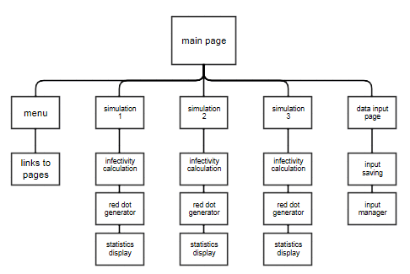

## Menu

There are going to be 3 main classes on the menu page. They are all button classes, where all of them link into the data input page. However they will each assign a value for the page_selected variable which will be equal to the simulation that is wanted by the user. This will be used in the data input page.

## Simulations

In all of the simulation modules there will be three main modules in the program. These are: red dot generator, infectivity calculation and statistics display. These will vary depending on the numbers inputted when on the data input page.

The red dot generator module will take the data from the infectivity calculation and then use it to produce the red dots in the relevant cities. It does this by looking at the number of infected computers for each main city, when it does that it will apply a filter of 1 dot for every 1000 computers that are infected. When it knows how many dots there are it will put the dot in a specific circumference of the centre of the city. So if the total number of computers are infected is 10000 then there will be a small circumference around the city however if there was 100,000 then there will be a bigger circumference. The function of this means that will be more dots central when there is not many computers infected however when more get infected it will avoid overlap.

Infectivity calculations are a set of calculation which will determine how many computers it will infect in that frame. This is determined by three main factors, the first being the type of virus the worm for example will have a much higher infectivity rate due to it being an exponential growth however another may be fixed. The next is the number of connections between computers this is because that is the way a virus tends to spread. The last key aspect is the cyber security rating which will determine how many computers can be fixed per frame and how many don’t get infected in the first place. All of this data will be then fed through to the red dot generator.

The statistics display is a display in the top right hand corner which shows all of the information from the infectivity calculations module. However it also shows percentages as well as the numbers such as the number of computers left and number of computers currently infected with the malware. This is used for data analysis from both of my stake holders.

## Data input page

This page has two main modules the input manager and the input saver both of these modules are very linking into one another.

The input manager will be a group of classes which will change depending on what button you clicked on the menu page. There will be set questions which the user will need to input, next to each textbox there will be a bit of text which will tell the user the requirements and what the digit that you will enter will mean. For example a question that will be asked in all three simulations will be the cyber security level, the text next to it will say “this number will determine how strong the cyber security level will be this means how well the government can cure and prevent new infected computers from happening. The scale goes from 1-5, 1 being the worst (no government) 5 being the best (very difficult to do anything)” This will hopefully help the user understand how the simulation works.

The input saver will make all the variables global and allow the other modules to use it in the other pages. The function of this module will be to allow all the calculations to work and to improve the information that will be displayed in the statistics displayer.

## Described, justifying choices made, the usability features to be included in the solution.

I will now consider the design of my project. There needs to be specific requirements for my screens which were specified by my client. The colour scheme that is in place will be three main colours, C1 C2 and C3. C1 is going to be light green the purpose to compliment the other colours. C2 will be used for any buttons or cities and will be a light blue this is to go nicely with both C1 which is green and C3 which will be red. C3 will be a bright red this will be used as a red dot as described earlier in my project. When doing my research I found “plague Inc.” which used the red dot approach to showing the number of people infected. The map of the UK will be a darker blue this will work well with the simplistic feel of my colours

## Design

This will be the home page where when you start the program you will start in.

Menu

Help

## Cyber security threat

This is the first colour being used as a background. The green compliments the blue to make it stand out more to the younger years

This is an illustration of what the second colour will look like in practicality.

There is no red on this page due to this not being the main simulation page which is where the red dots will be located to represent the spread of the virus.

The function of this page is to determine what simulation you want to go to. It is also to inform the user of the virus that they will be modelling

Simulation 1

Simulation 2

Simulation 3

Description

Description

Description

These text boxes are using a black text on white background due to my clients to make the program look professional. It also makes it easy to read for the year 9 classes

This is another example of when my second colour will be put into use. I will use black colours for professionalism which both my clients wanted however it still sticks to the simplistic art style that my program is trying to replicate

Back

This is the back button it will take the user to the previous page. This will help with easy navigation.

[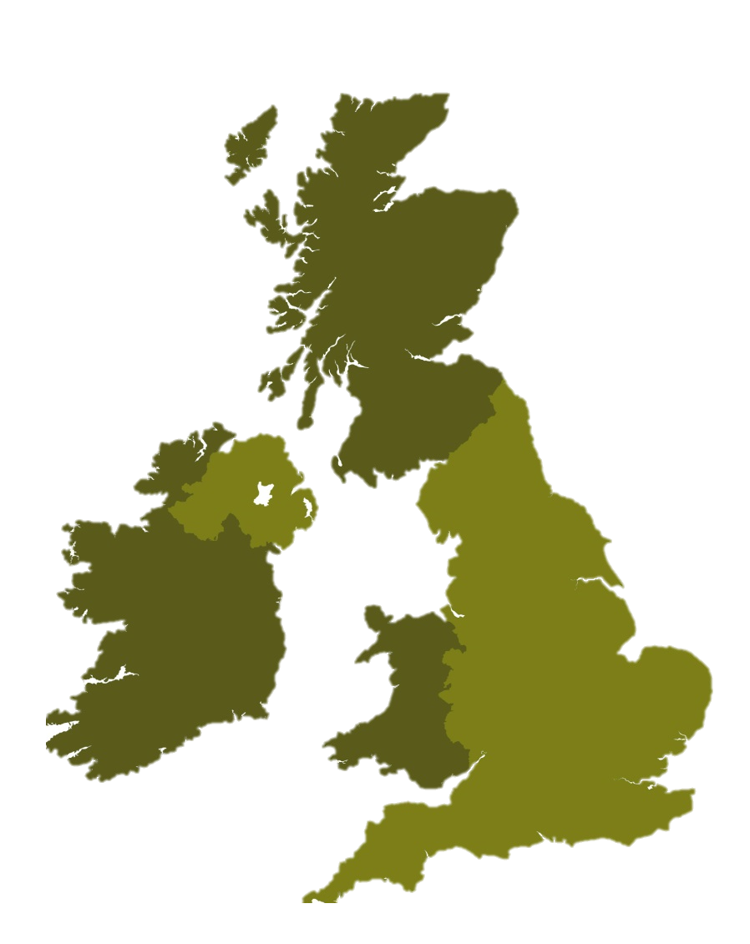](https://www.google.co.uk/url?sa=i&rct=j&q=&esrc=s&source=images&cd=&cad=rja&uact=8&ved=0ahUKEwj4ktXJq7jWAhUFuRQKHYDKAFsQjRwIBw&url=https://maproom.net/shop/simple-outline-map-of-britain/&psig=AFQjCNF13Zm1XbYIRUVsqre1LV2FqPs8JA&ust=1506154147160620)This will be a general screen design for the main simulation page where there will be all of the relevant data and graphical representation of the virus’ spread

Back

|  |  |  |
| --- | --- | --- |
|  | **%** | **No.** |
| **infected** | **//** | **//** |
| **Not infected** | **//** | **//** |
| **Security level** | **//** | **//** |
| **Infected London** | **//** | **//** |
| **Infected Norwich** | **//** | **//** |
| **Infected Edinburgh** | **//** | **//** |
| **Infected Cardiff** | **//** | **//** |

[](https://www.google.co.uk/url?sa=i&rct=j&q=&esrc=s&source=images&cd=&cad=rja&uact=8&ved=0ahUKEwi88a_lr7jWAhWBWhoKHbsNBrAQjRwIBw&url=https://www.iconfinder.com/icons/170240/center_gps_location_map_marker_pin_pos_site_icon&psig=AFQjCNEAvAAvBLSOrh5U9uUdotCMsav6oQ&ust=1506154729185008)

This is where all the statistics go where there are three coulombs, and 7 rows. The reason why it is in black is because I need it to look professional.

[](https://www.google.co.uk/url?sa=i&rct=j&q=&esrc=s&source=images&cd=&cad=rja&uact=8&ved=0ahUKEwi88a_lr7jWAhWBWhoKHbsNBrAQjRwIBw&url=https://www.iconfinder.com/icons/170240/center_gps_location_map_marker_pin_pos_site_icon&psig=AFQjCNEAvAAvBLSOrh5U9uUdotCMsav6oQ&ust=1506154729185008)

[](https://www.google.co.uk/url?sa=i&rct=j&q=&esrc=s&source=images&cd=&cad=rja&uact=8&ved=0ahUKEwi88a_lr7jWAhWBWhoKHbsNBrAQjRwIBw&url=https://www.iconfinder.com/icons/170240/center_gps_location_map_marker_pin_pos_site_icon&psig=AFQjCNEAvAAvBLSOrh5U9uUdotCMsav6oQ&ust=1506154729185008)

This is the green background which is consistent throughout my program. This makes the whole program hold together

This is the first demonstration of the red colour in my program and I think it is very visible from the green map

The colour of the icons is a representation of C2 which will be used in the project. This is because it is an activator which means that it comes under my C2 bracket.

Like the previous page this is the back button where the object of it is to allow the user to go back a page whole program hold together





## Testing strategy

In my program I will use many different types of testing strategies such as white box, black box, alpha, beta and destructive testing. The purpose of this is to remove bugs and issues with the program.

White box testing is another type of testing strategy which works by looking at the each line of code and determines if there is more efficient way of doing the code. The difference between this and black box is that this looks at the way the code works unlike black box which just uses the output.

Another testing strategy that I will use is black box; I will use this by putting in data types and just looking at the outcome from the program this means that it has no implication to how the data will be outputted (looking at the code itself).

Beta testing will be done and it will involve external people testing the product on a large scale testing to see if there are any issues with the program such as logic or syntax errors.

Alpha testing is when the game is still in development with some sections of the program still not implemented into the game and peoples within the company test the program to see if there are any syntax errors.

Destructive testing is when someone tries to break the program by doing specific inputs that would break it. They will use both borderline and extreme data to do this. The function of this is to make sure that there is nothing that the user can do that will break the program. Considering that one of my target audiences is year 9 students destructive testing will make it so that it is next to impossible for there to be an error when using it. This also applies to the cyber security firm and it would be very bad if it broke mid presentation.

## Test data

There are three main types of test data these include; valid data, invalid data and border line data. Valid data is when you put data in which fits the requirements, for example if there was a text box which needed a number between 1- 10, 5 would be an example of valid data. These data will be applied into the testing strategy which was listed above.

Invalid data would be a type of data which is just wrong so using the example above if I put J or 15 then that would be an example of invalid data. The reason why I would use this is to see if the program will ether output a syntax error, or carry on and brake later in the program. I will make it do some validation to make the program ask for a new number this will prevent errors from occurring.

Border line data is type of data which is on the edge of the program. Using the example above if I inputted the number 1 or 10 then that would be borderline data. This is used to test the boundary of what the computer defines as 1-10.

## Plan for iterative development process

During the development of my project I will be following an iterative process this is because of many different reasons. One of the reasons for doing a rapid application development (iterative process) is because it will produce many proto types which result in the stake holder getting the best product that they want due to them being able to ask to change things during the development process. Another advantage of doing it as an RAD (rapid application development) design is that it means that I can actively change what is happening to the project after doing another iteration unlike the waterfall method which means that you can’t change it. During each of the iterations there will be several stages the first of which will be the design section this is when I will make pseudocode this is to make sure the problem can be broken down into a computational model. The next section of the iterative process will be to code it, in this section I will both be coding and actively testing it by myself. The test data that I will use in this section will just be normal data; this is to check for syntax errors and issues with the code. The next stage will be the testing, this is where there will be all types of test data, there will be destructive, borderline and extreme data, this will all be on top of the normal data that I will constantly be using. The final section will be the evaluation this is when I will look to see if I have done the relevant criteria for that iteration. When all stages are complete the sequence will go back to the top and do it for the next iteration until the end of the process.

## Iteration 1

During this iteration I will be making the aesthetics for the game this will include the buttons, titles, pages, maps and red dots in prep for later. This will involve me using photoshoot to make the models look aesthetically pleasing and giving them the relevant names which are needed to make the client know what each button corresponds to.

Success criteria for iteration 1:

1. Make the models for the buttons
2. Make the models for the

## Iteration 2

During the second iteration I will make the buttons link together. And do the help button which will generate the help text for easy navigation

Success criteria for iteration 2:

1. Make all buttons link to their relevant pages
2. Make the help button display text which will help the user navigate the program

## Iteration 3

During this section of iteration process I will program all of the spreading algorithms to do the calculation this does not include the generation of red dots that is in the following stage. I will need to program the input system for the spread algorithm to work. This will involve using a library.

Success criteria for iteration 3:

1. Make working inputs for the formula in the data input page
2. Calculate ‘how many new computers infected’
3. Calculate ‘how many computers resist infection’
4. Calculate ‘final computers infected’
5. Make this process repeat over and over until it is finished.
6. Do steps 2-5 for all three simulations.

## Iteration 4

This is the final iteration and in this I will implement the abstraction of the game by making all the red dots generate.

## Provided evidence of each stage of the iterative development process for a coded solution relating this to the breakdown of the problem from the analysis stage and explaining what they did and justifying why.

## Iteration 1

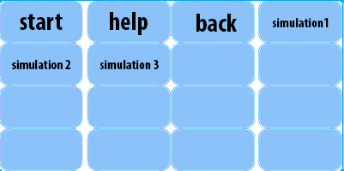

When designing all of my designs for my project there will be a variety of buttons, in preparation for that I did a template of identical buttons that I would just add text to. This works for the majority of classes that I will have in my project. However this grid of buttons doesn’t cover all the classes that will be needed for the project for example there is a title on the opening page which is needed and has no other function than for aesthetics. For this I used a website that makes good titles. The URL for this is:

<http://flamingtext.com/>

In my structure diagram I have the first level being all of the different screen that will be in the project. This means that I had to create them all with backgrounds and add all of the relevant buttons onto them. As shown on the diagram below this is all the things that I did in this first iteration.



On the right hand side of the screen there is a class editor and for adding the new pages I went onto the world editor. And then right clicked the master class (world) and then clicked add new subclass. This was to make a sub class which means that it has the default settings on it which is what I need. I also did it under the world classes so that it means that I could link to them by using the buttons unlike the actor classes which would mean that they are localised to the world they are loaded on.

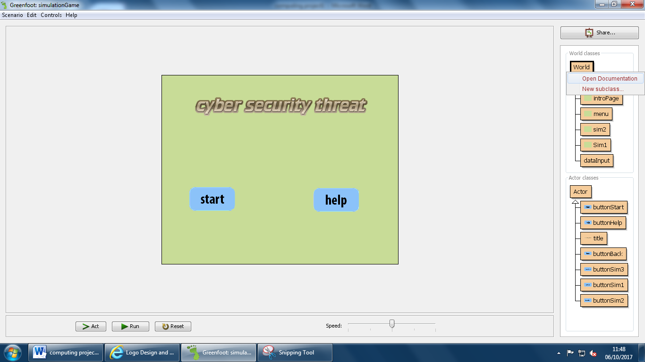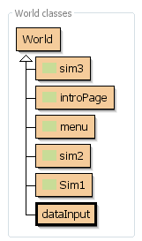

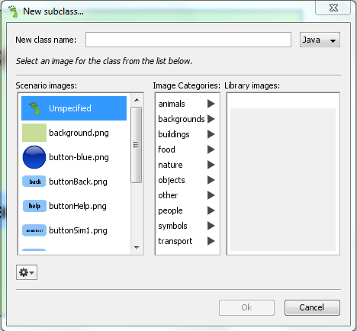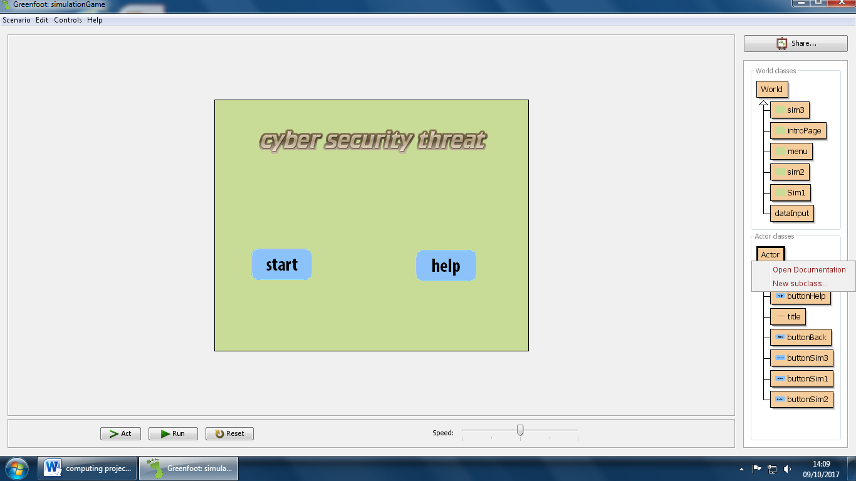When I had finished doing all my different pages that I needed for my project I created the actor classes which was a large variety. I first created all the buttons followed by the title followed by the statistics area and then finally all the maps/locations for the simulation area. some of the buttons that are currently been made are shown here. Also the way that I created them is shown below this shows the screen where each new actor was made however I needed to import my own assets due to the pre set ones not having the specific button types that I needed. The reason why I made them in the actor classes is because it makes linking between pages very easy due to the greenfoot click function which works for the actor classes and also means that I can change the size of them so that they don’t fill the whole page like the world classes do.

When creating my simulation pages I had to alter the size of the background I did this by going into the code for my page (sim1). When there by deafult it was 500 pixels by 400 pixels. The way that greenfoots defines its size is by using the comand super. It needs three inputs (length, width, no. of pixels) I changed the number for length by width to 500 by 600 and kept the number of pixels the same.

 

Also so that all three simulation pages have the same positioning of all classes I coppied the information in the prepare function.

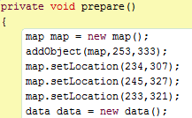sim1 sim2 sim3



The reason why I did both of these functions (size of screen and identical screen) was so that the program looks to a professional standard.

The final product looks like the print screens below:

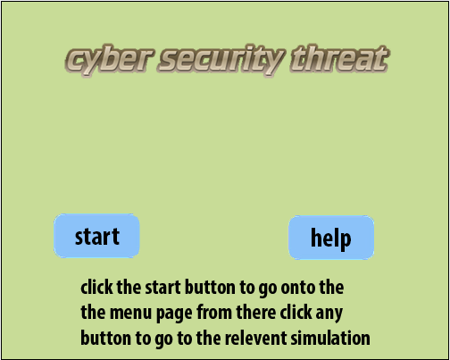 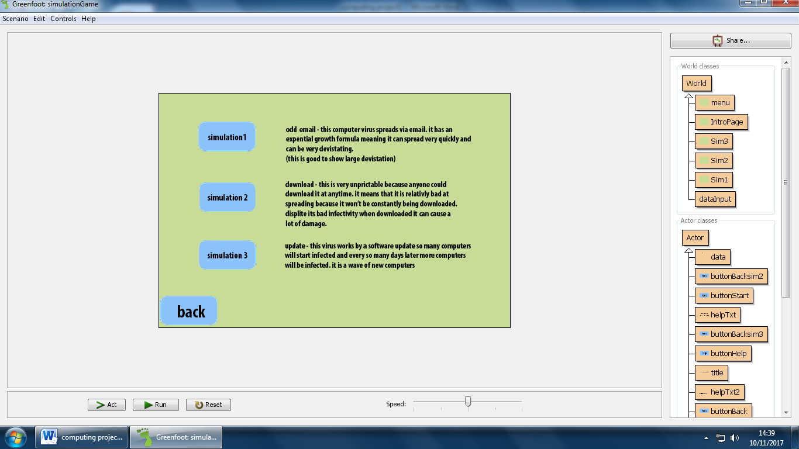

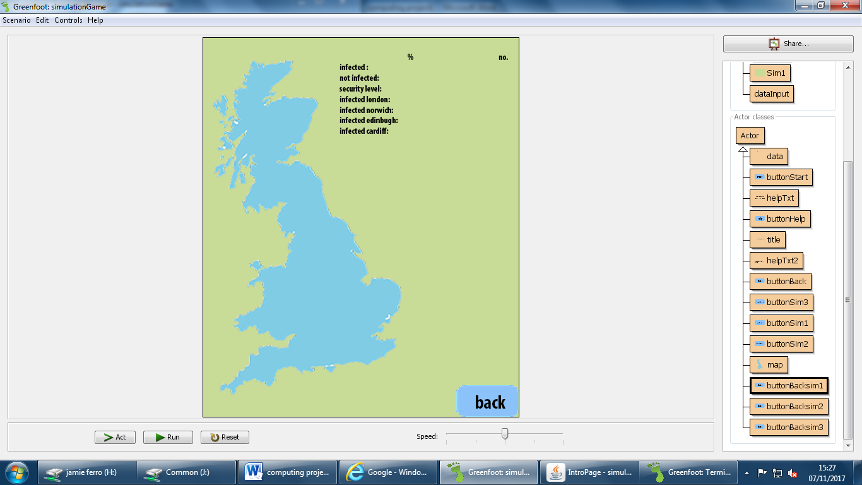

|  |  |  |  |  |
| --- | --- | --- | --- | --- |
| No. of test | What should happen | What does happen | improvements | Test data |
| 1 | The page is meant to be consistent between pages this means that the back button should be located in the same section. | The back button was slightly off this meant that it wasn’t consistent throughout the pages | I went into the world code and checked the spawn location of the button and changed the x and y coordinates. | n/a |
| 2 | The intro page needed to be symmetrical | The buttons didn’t line up on the y axis this was due to there being no auto grid lock on Greenfoot. | So like in the previous issue I changed the coordinates so they would be on the same y plane. | n/a |

## Beta testing

When I had finished I showed a picture of all of the screens when they were finished to my stake holder to make sure that it was expectable and I pointed out any changes from the original screen designs. The first difference from the screen designs are that I changed the colour of the title this was due to the limited number of combinations that my title software had, however the stake holder thought it would be ok due to its bright colours and its ability to engage people because it stands out. I also displayed the help text to begin with this meant that the help button would now just remove it in case it became annoying. The back button has been moved this because the screen design that I made wasn’t to scale meaning that the UK map was too big and stretched to the corner and meant there was no room for the button at the top, I made a decision to move it to the bottom which my stakeholder also agreed on.

## Iteration 2

In this iteration the function of it is so that the project will all link together this is by opening and closing the relevant screens of the project so that the menu and all other pages work correctly.

Using a simple bit of code I was able to make any page open when the button was clicked. I first did an if statement for when the button is clicked it would do something. When looking for the code for this by going on the forums I found it at <https://www.greenfoot.org/topics/2272>



Now that I had the code to check if the button was pressed I needed to find a way for the button to make it go onto a new page. Looking at a Greenfoot forum I found the code that I would need.

URL: <https://www.greenfoot.org/topics/2245>



This is the code that is needed to make the page go to another page.

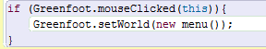

This is the code now for my start button. What happens is that when the button is clicked it will activate the code inside which will change the viewed world to the menu. For my other buttons I will use the same code but change the menu into another map.

When creating the help button I had two learn about transparency so I could make the text become invisible and visible. Using the command

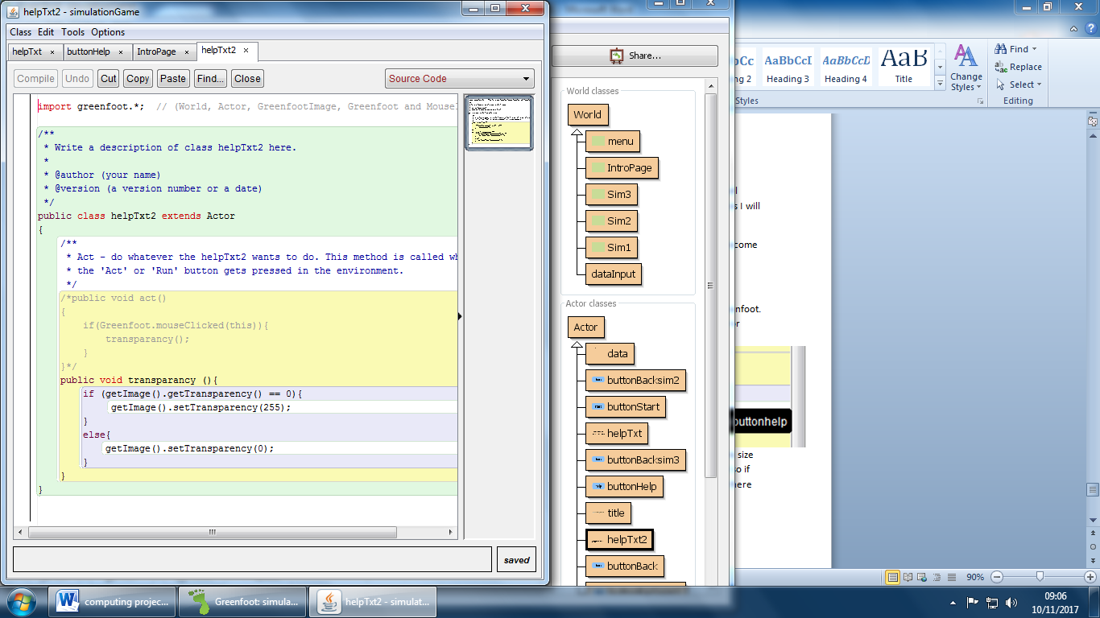

This would make it completely visible this is because the max was 255 and the lowest was 0 so I was just going to do this by adding it in the if statement by using the when clicked command that I have used for all my other buttons. I also added an else so that it would go invisible.

When doing the help button I came into many issues these were due to the limitations of Greenfoot. The first one was due to the ability to reference another class through the world. A syntax error appeared when doing this.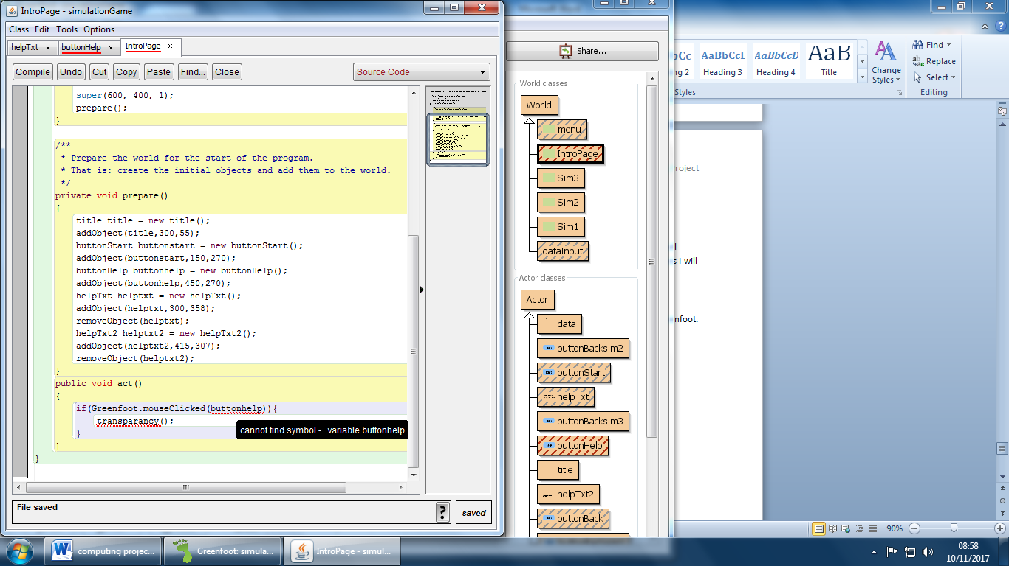I then came up with a way of doing it by moving the help text under the button and extend the size of the image up using Photoshop. When this was done I did the usual transparency command so if you clicked the button you would be clicking the text. However this also didn’t work because there was no way to make the text start invisible without coming into the same issues before by referencing a button from the world class.

When all of this worked I talked to my stakeholder and we both agreed that it was not worth continuing to try to fix this issue and instead the help button will either be removed or I will come back to it at a later date, this was because it wasn’t worth so much time.

|  |  |  |  |  |
| --- | --- | --- | --- | --- |
| No. of test | What should happen | What does happen | Improvements/ how to fix it | Test data |
| 1 | When the any button is clicked it should do an action | When clicked the game wouldn’t recognise that it was clicked | The G in Greenfoot wasn’t capitalised so it meant that it wouldn’t do anything. | I used normal data which was when it was clicked to check if it would do its function. I also did abnormal by holding the button. When I did it, nothing would happen until I let go of the button. |
| 2 | When the help button was clicked it should make the help text become visible | Nothing worked the text was always visible without the button being pressed | The bounding box of the text was too big so it overlapped with the buttons resulting in the buttons not being clicked. I fixed this by going into Photoshop and cropping the image. | n/a |
| 3 | When the help button was clicked it should make the help text become visible. (continued) | The button was being clicked however it didn’t work because the two actors couldn’t reference each other. | I then decided to make the text always visible so that there was no input required | n/a |

## Alpha testing

At the end of this iteration I needed to go through the program to make sure that it works efficiently. I did this in a short video to show how it works. When doing this I have made some adjustments such as keeping the

## Beta test

When I gave this to my stakeholder they said the button switching was good. And wouldn’t need any further work on due to it not being a big part of the program. The help button sadly didn’t work however my stakeholders said it would be fine because the navigation wasn’t particularly difficult to use.

## Evaluation

Success criteria for iteration 2:

1. Make all buttons link to their relevant pages
2. Make the help button display text which will help the user navigate the program.

At the end of the second iteration there have been one issue with the help button however the navigation of the program works successfully. The first criteria is to ‘Make all buttons link to their relevant pages’ which is show clearly in the alpha testing. However the second criteria is to ‘Make the help button display text which will help the user navigate the program’ this is not as successful due to the inability for Greenfoot to refer between static and non-static objects.

## Limitations

Due to the limitations of Greenfoot (java) I have made a decision to change programming languages from Greenfoot to unity 2d. This is because it won’t have the same issues as Greenfoot when referring to other classes. It also means that in the 3rd iteration I will not need to import and do long code for the inputs of text boxes. Also, the ability to store data over multiple pages. Now that I have changed I will start from the beginning and start doing the first iteration where I will need to make the graphics. I will still stick to the original iterative process following the same steps as before.

## Iteration 1

The first part of my game in needed to make the starting page this has two main buttons and one title. Due to me making it in unity I also needed to make a canvas to put everything on. Also a background colour.

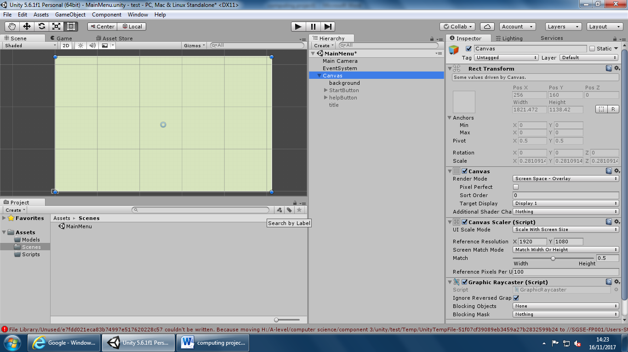

This is the image of the background it is the colour that me and my stakeholders previously agreed on. After that I added the start button

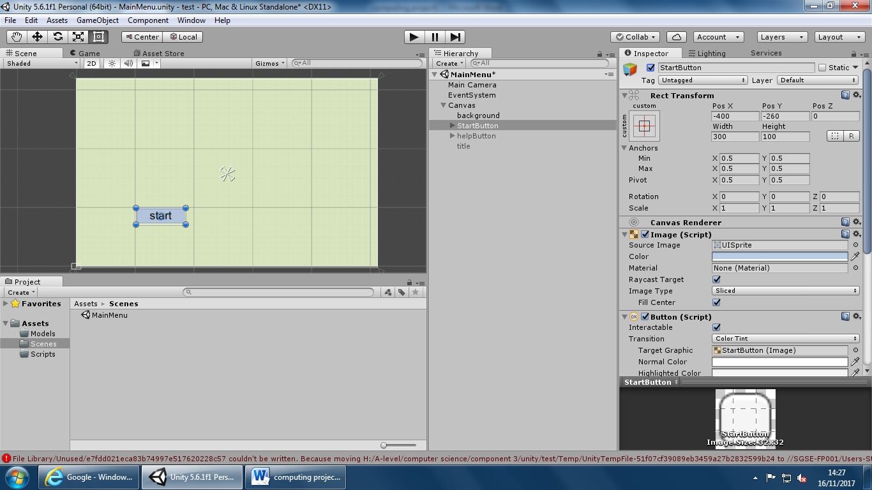

This is the start button I did it by right clicking my hierarchy and going onto UI button

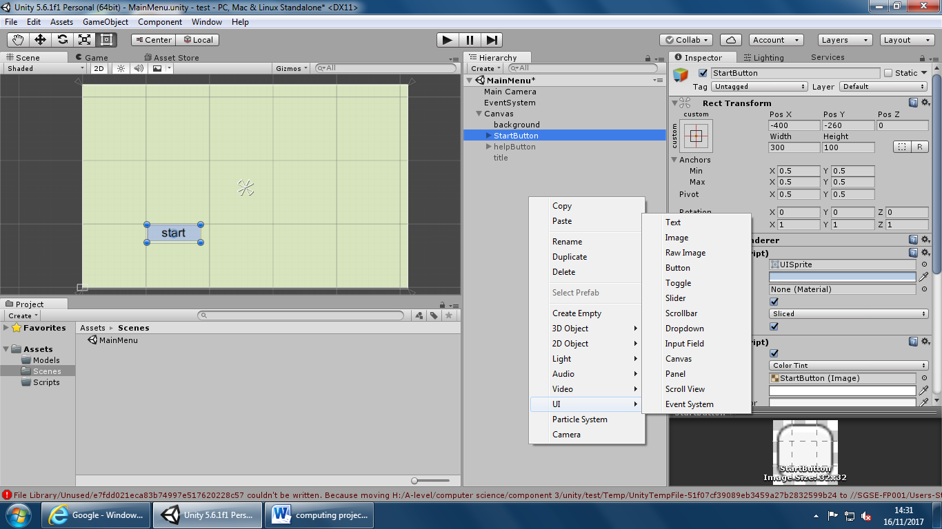

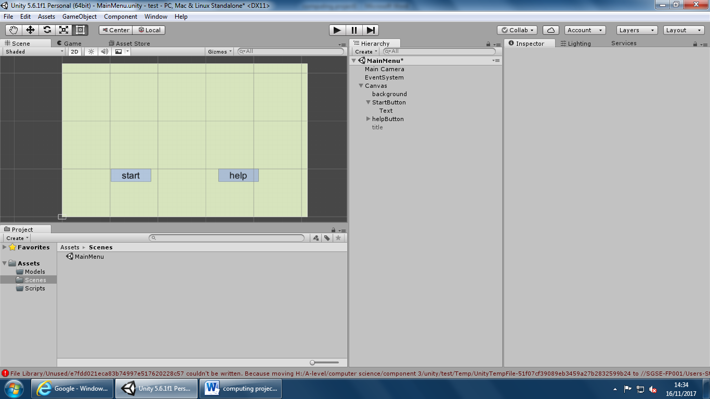

When this was created I changed the name to start button and then the text underneath

When I had completed that for the first slide I did the same for all my other slides. I just made an empty object and put one page under it so I could move them all together. I kept the background the same and just changed the content.

When making the data input page I made the background consistent with the other pages however made the input fields white.

The final screens look like this

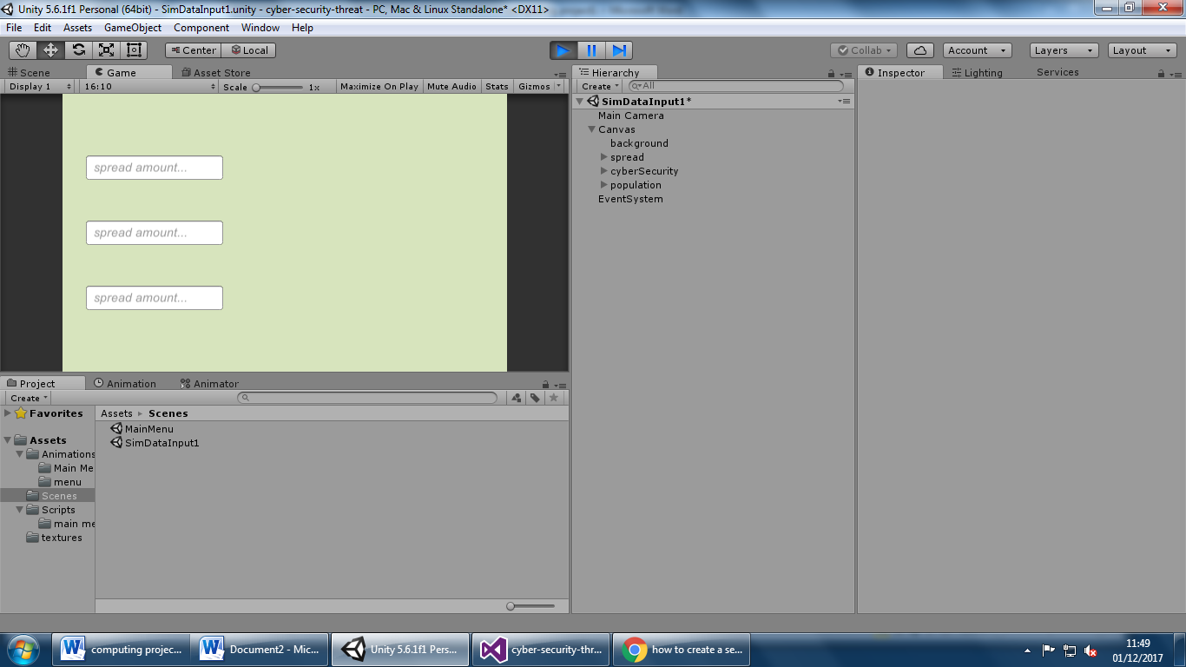

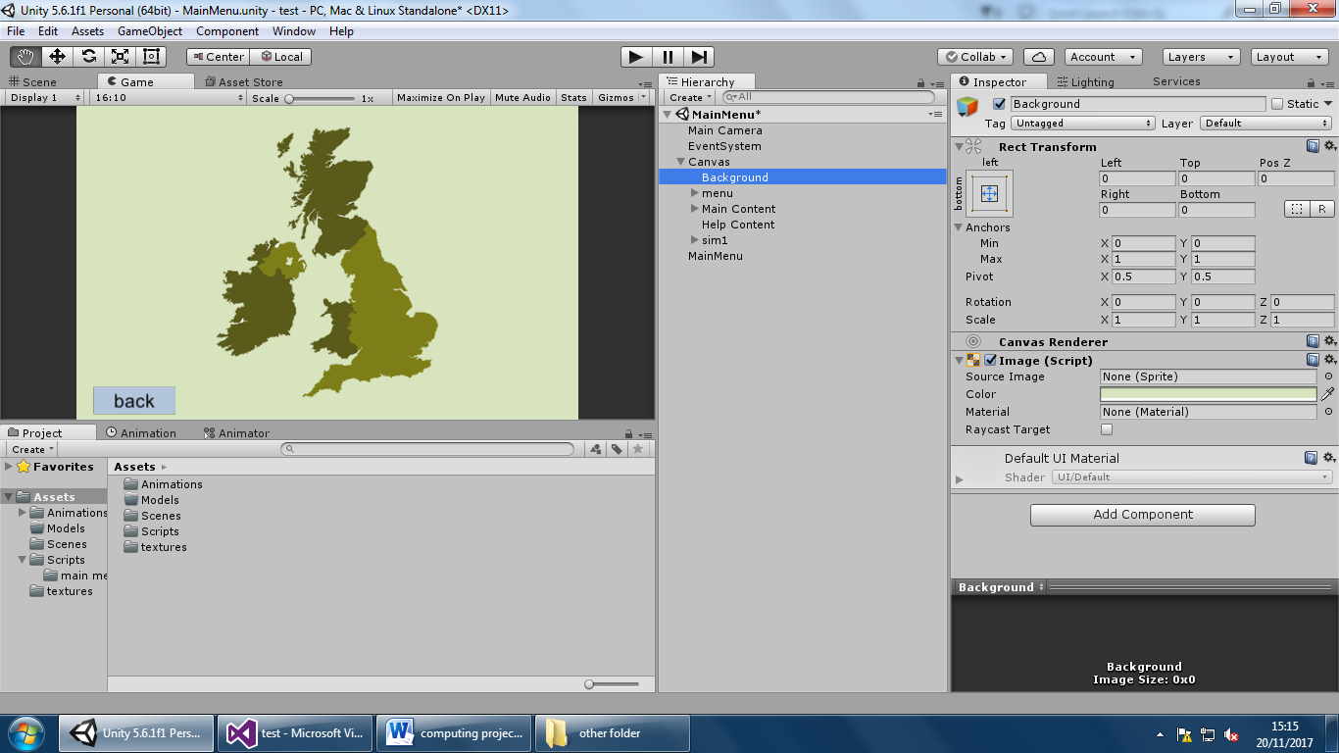

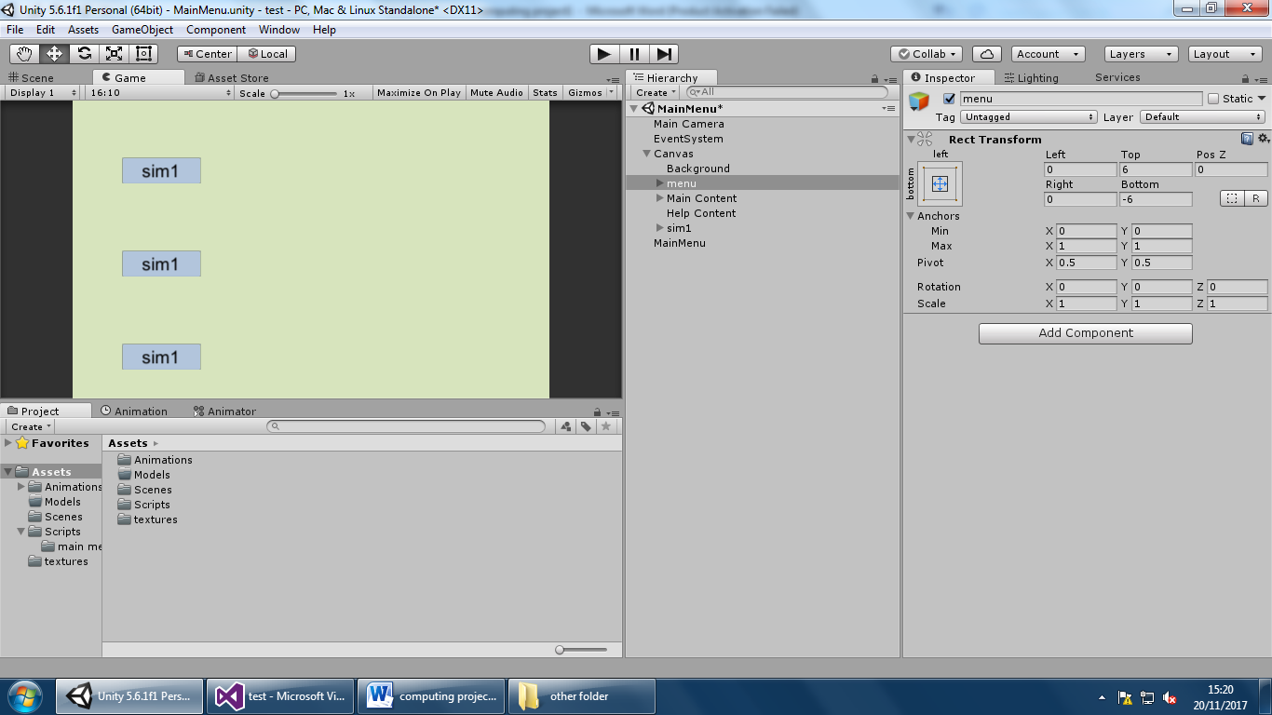

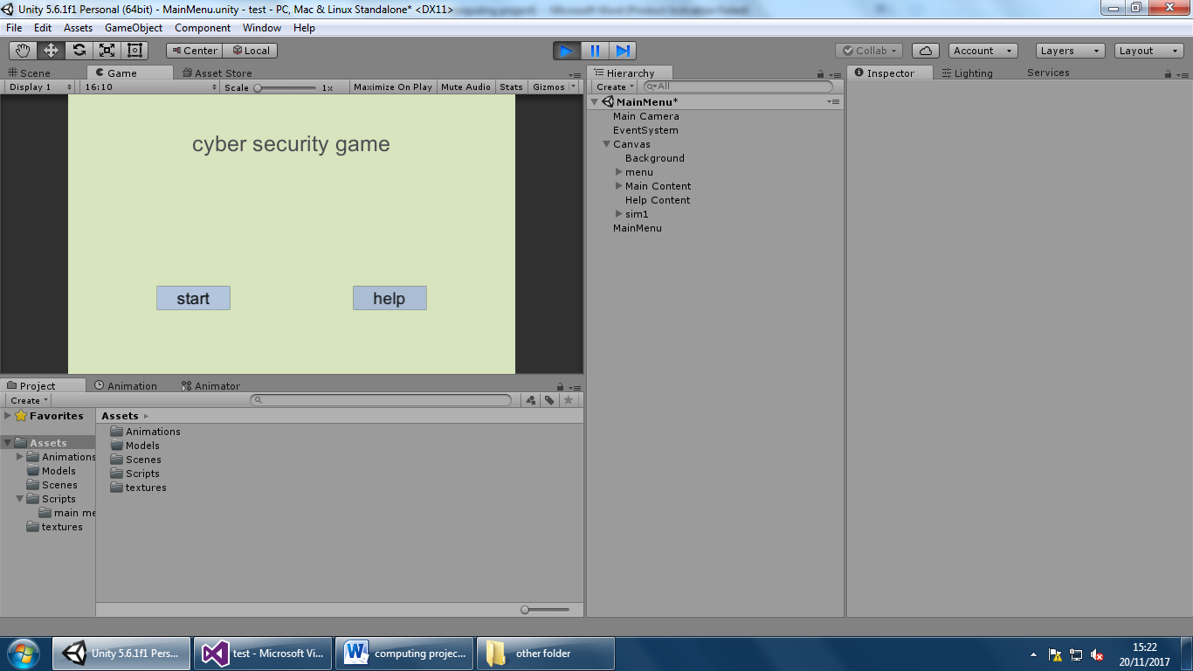

## Iteration 2

By clicking on the window tab with the animator subsection a new window opened. It looks like this

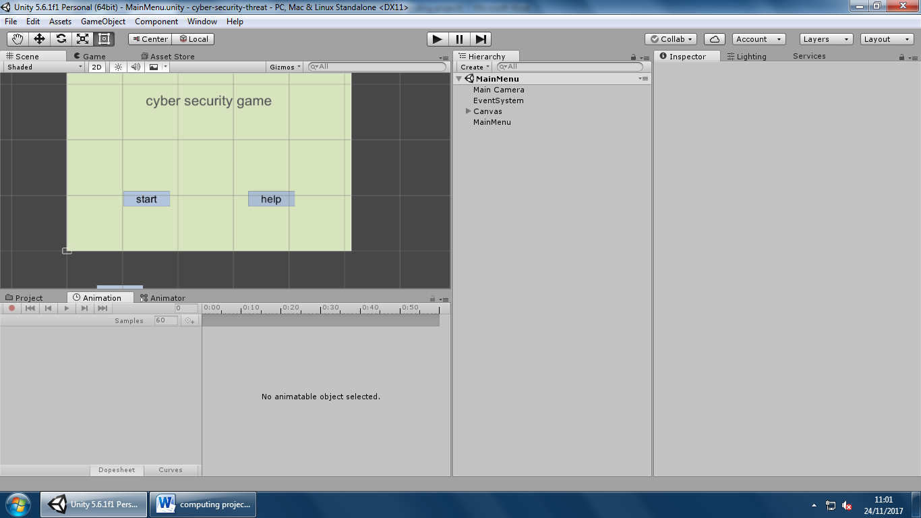

When this appeared I clicked on my opening page game object. when this happened it came up with the following screen

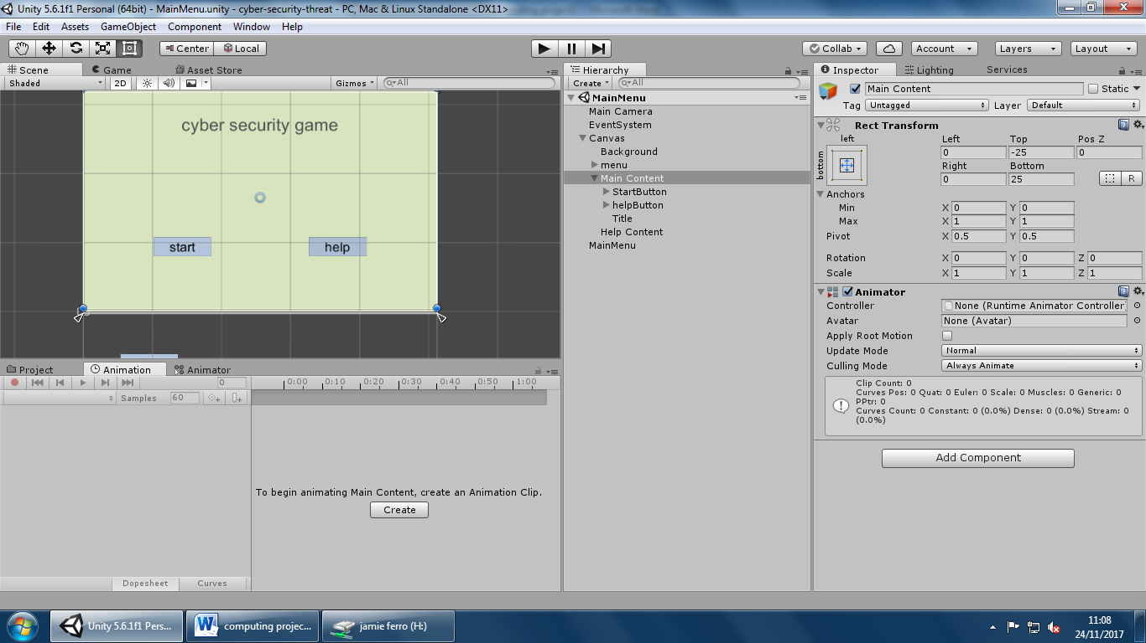

I then needed to create the actual states of my animation. These include idle, move on, Move off.

The idle state just means that when the screen isn’t being acted upon the screen will stay stationary.

The move on animation means that when the back button on another page is clicked this screen will be moved back onto the screen in a fluid movement.

Finally the move off just means that when the start button is clicked the screen will move off and a new screen will replace it.

In the animation tab you can see the stages of the moving page. You can see it work in this short video

However at the moment nothing happens when you click the start button this is because of two reasons. The first reason is that there is no connection in the animator. What I needed to do was go onto that tab and then.

When I was finished it looked like this.

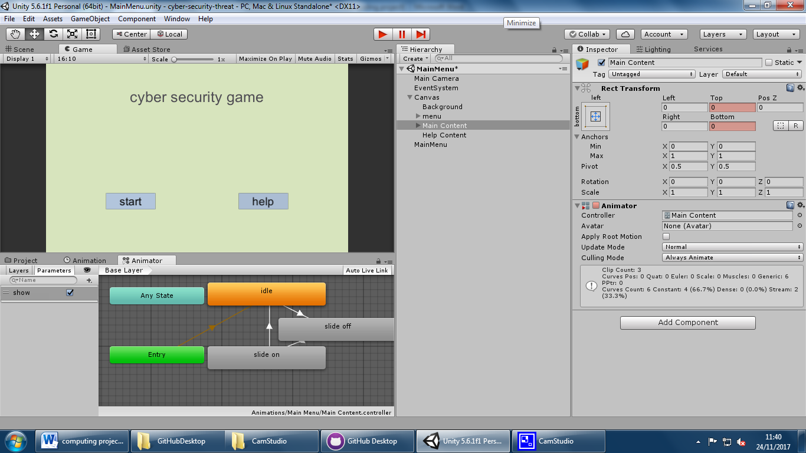

Now I needed to do the code for when the button was clicked that it would do something.

I then made a c# script and then did the following code

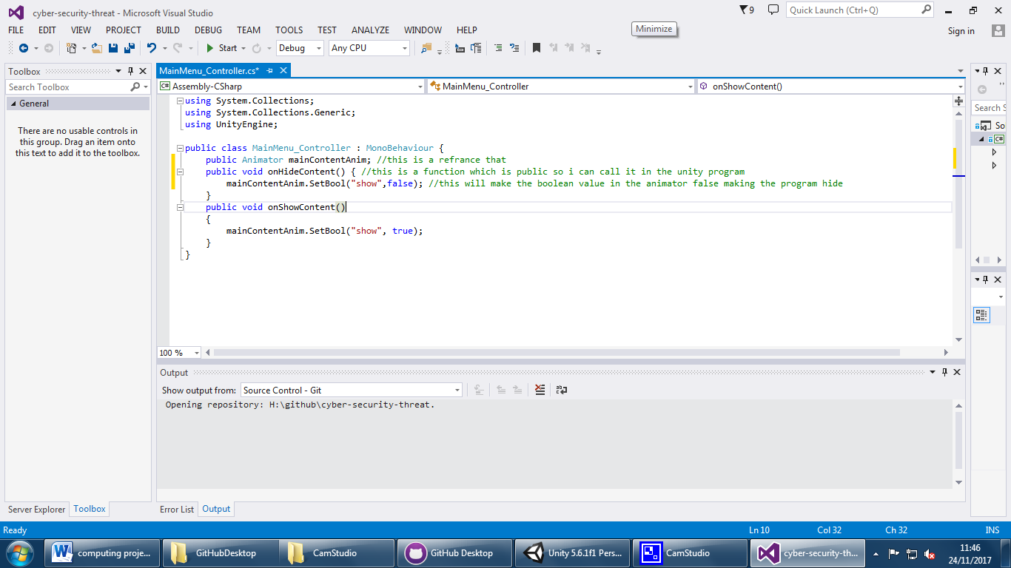

The code will mean that I can apply this to an empty game object. then add it to the onClick function of the start button.

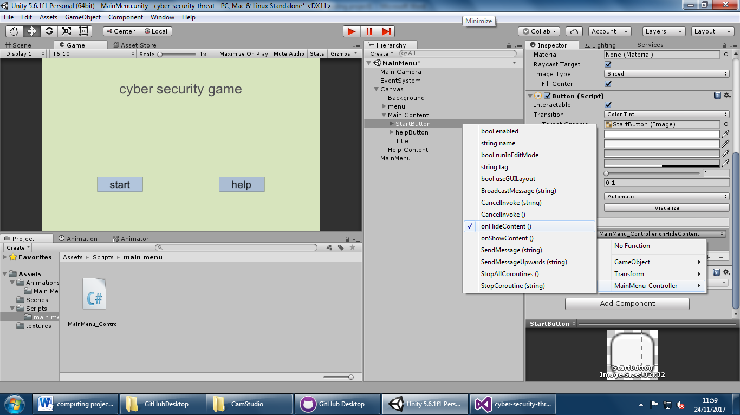

When this was done it meant that when the start button was clicked it would mean that the screen would go down. You can see this in this video. The next step was that I would need to do is to do the same animation as before.

I then added a new script which was the controller for the menu. After that I just set the on click function in the start key to both make the main screen go down and the menu go up so that it transfers. I then created a back button and did the same except in reverse so to make the menu page go down and the intro page go up. You can see this in my video.

When this was finished I talked to my stake holder and they said that they liked the way the screen came up and down. It would be entertaining for young kids.

## Linking pages

When going between the sim1 button and the data input page for simulation 1 there was some code needed to close the first page and open the second page. The code that I used was 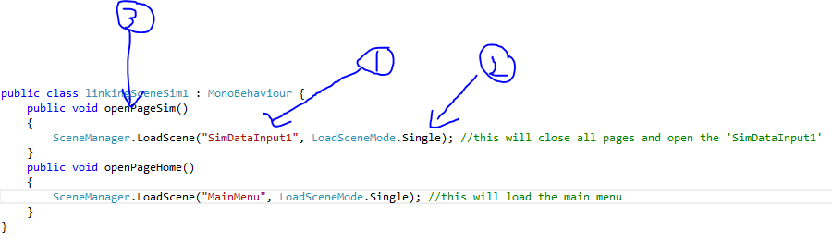

(1)

This part of the code is just used to say which screen needs to be opened. The “SimDataInput1” is the name of the page.

(2)

In this command there are two different options. There is additive which means that it adds the page without closing the previous one

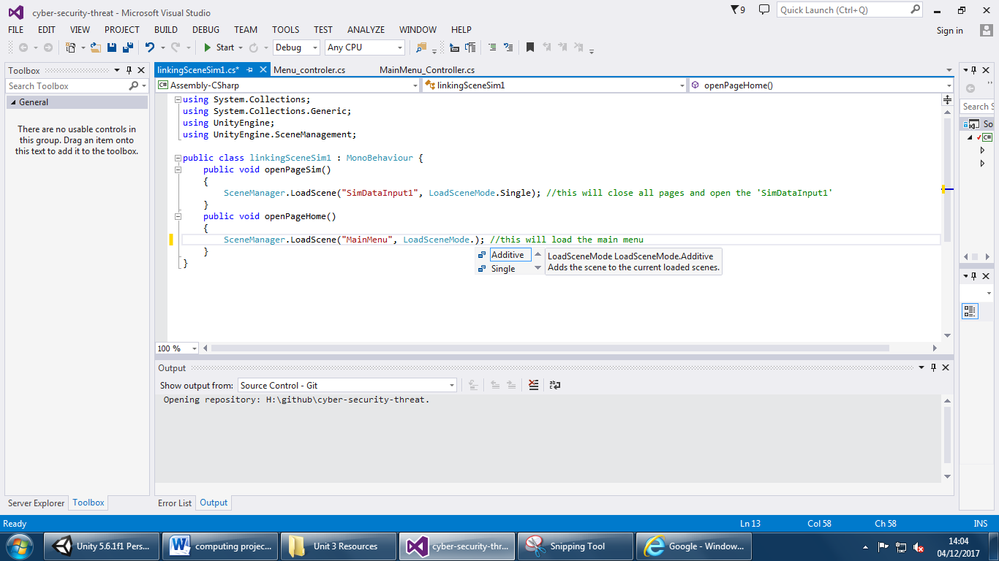

Or single which means that the old screen is closed and the new screen opens.

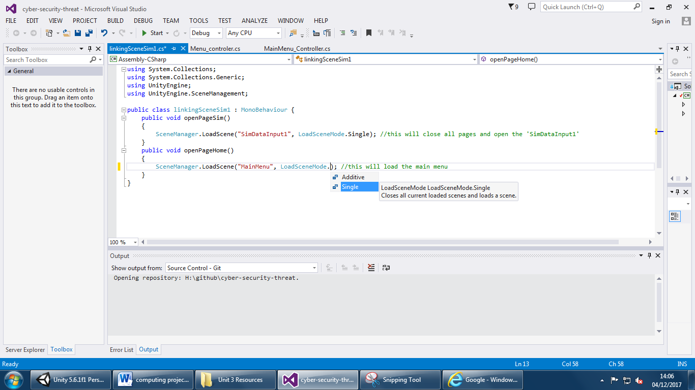

(3)

This is a procedure which can be referenced in unity (as long as it has public) this means that when applied to an object in unity specific code can be targeted to open and close relevant pages.

After doing this code I needed to add a game object and apply the script to it then drag the game object into the on Click function on each button. You can see how I did this in a video

The finished code for this is 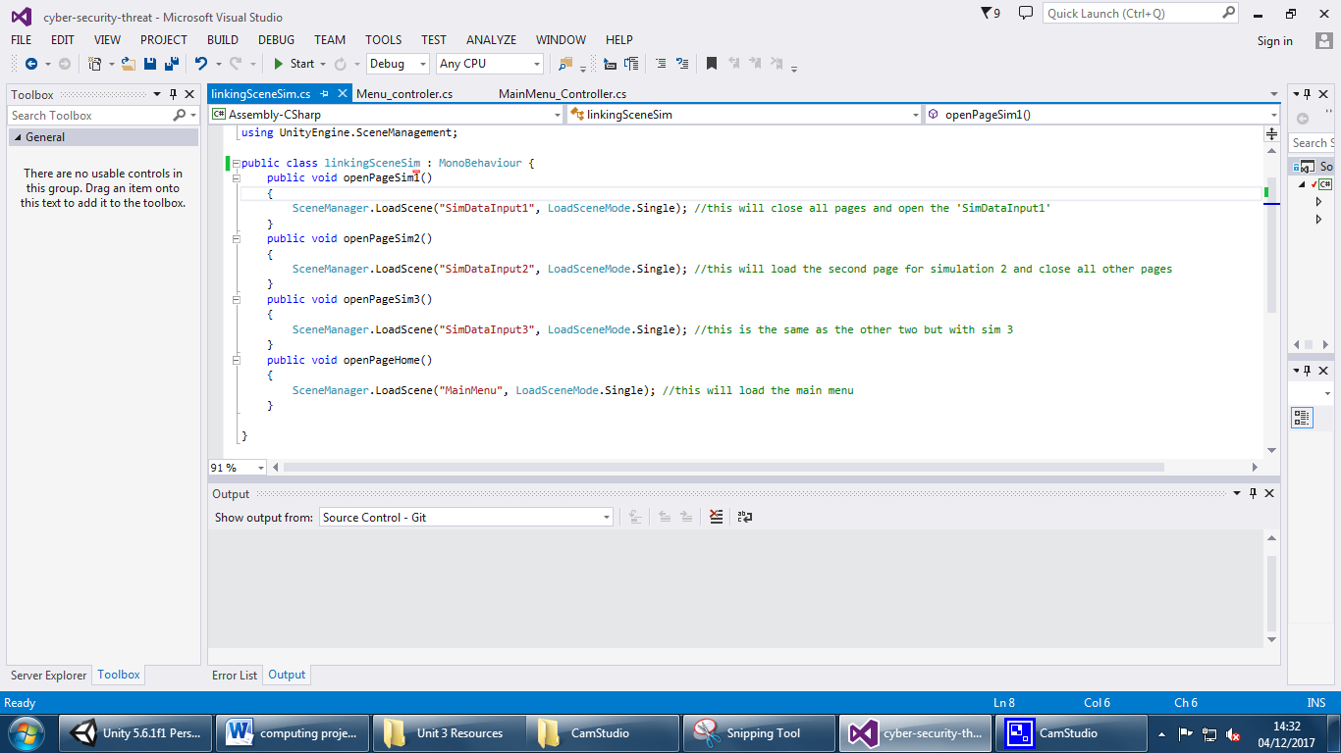

After this I then started on the help button. This was relatively easy, I started by making a text game object which I then typed my help advice for navigation around the program. After that I made a C# script which makes the help text enabled this is because by default it is not active so they can’t see it when they first go onto the program. The final code looks like this

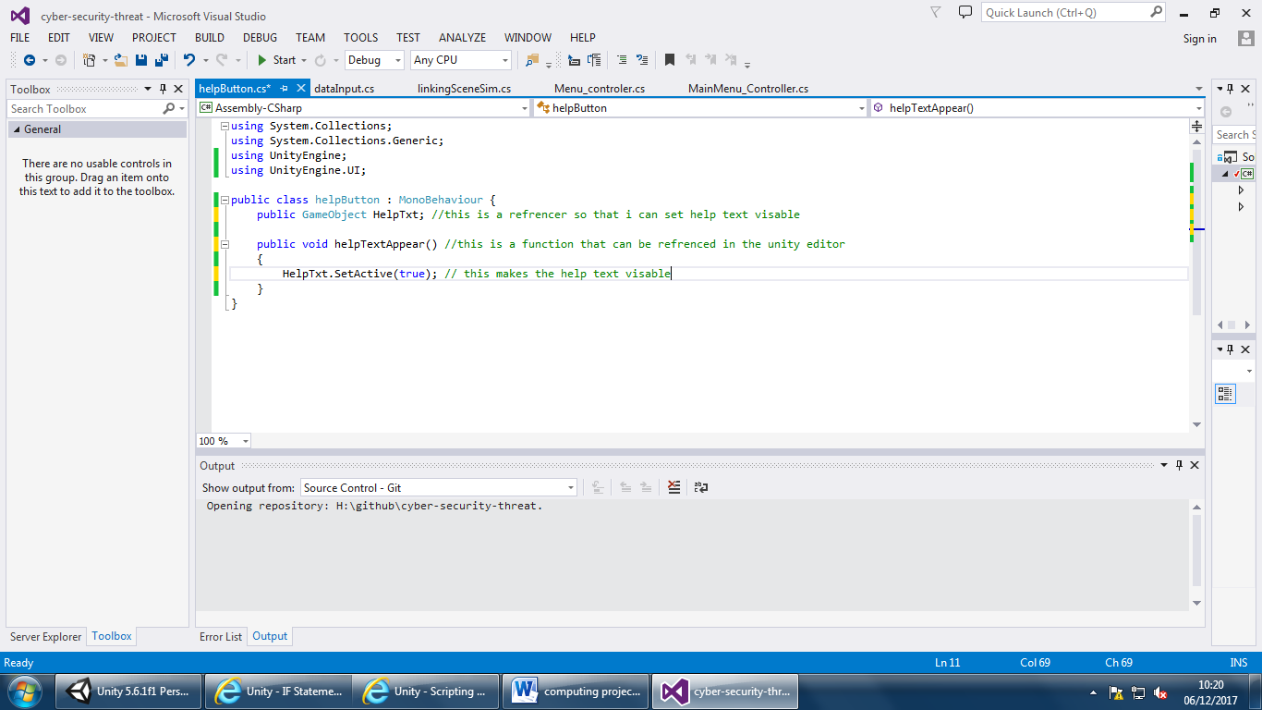

This is what happens when the button is clicked

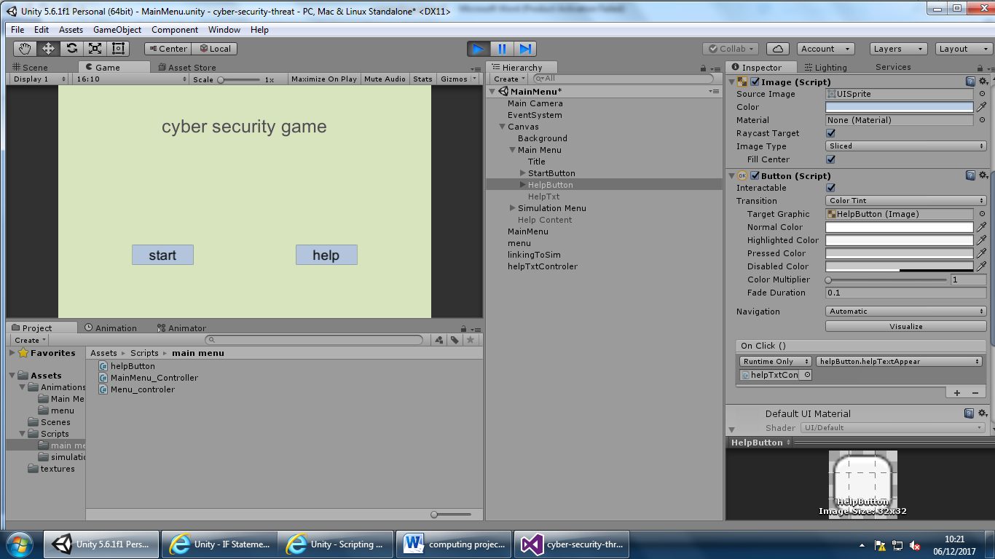 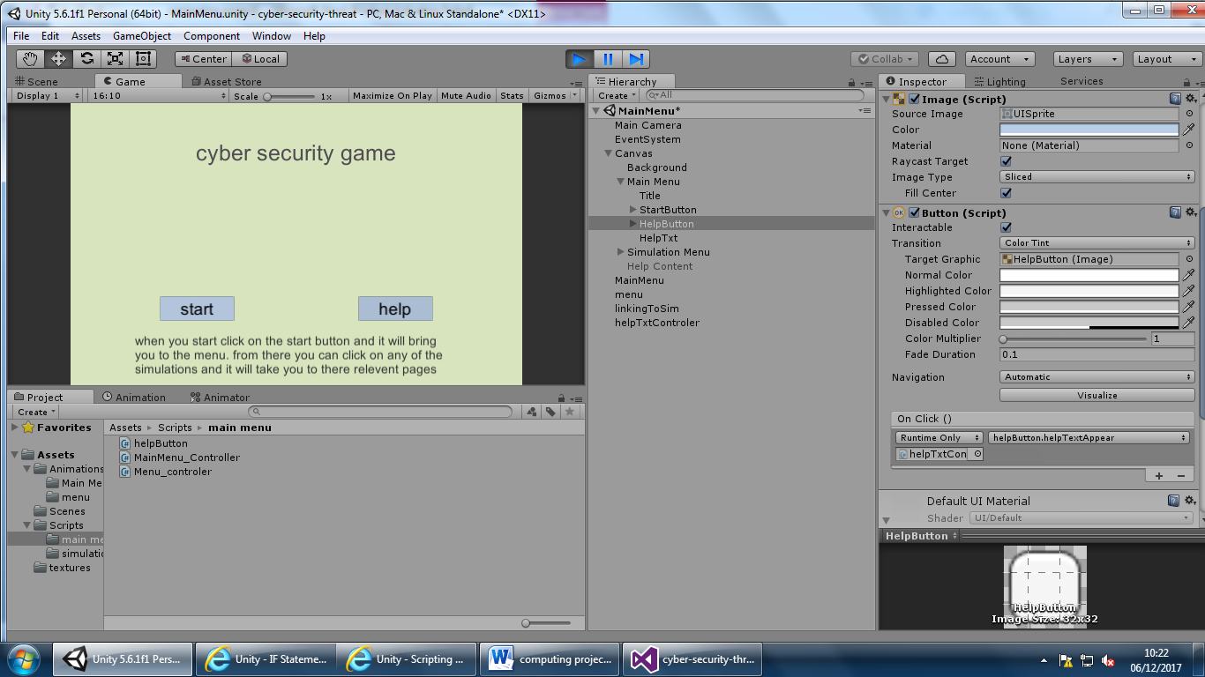

## Evaluation

At the end of this iteration my main aims where to

1. Make all buttons link to their relevant pages
2. Make the help button display text which will help the user navigate the program

The first part of the success criteria for this iteration was to make the pages link together. This is clearly shown in the animation part of this iteration. The start screen clearly transitions onto the menu scene. Then all button clearly link to their respective input pages, when there the back buttons also go back to the main intro page. This means that the first part of the success criteria is a success. The next section of this iteration was to make the help button to display the help text. This is a success because when you click the help button the help text is displayed you can see this early in my development of the code.

## Iteration 3

Success criteria for iteration 3:

1. Make working inputs for the formula in the data input page
2. Calculate ‘how many new computers infected’
3. Calculate ‘how many computers resist infection’
4. Calculate ‘final computers infected’
5. Make this process repeat over and over until it is finished.
6. Do steps 2-5 for all three simulations.

For this I started by going onto my main input page for my first simulation. When I was on there I needed to do some validation on the input fields. This was because my program would brake if ether there was no data in the input fields or if the data that was in there was erroneous (string or a negative) the way that I did this was setting the content type to integer number, this would prevent it from being a string. After solving that issue I still had to make it so that it would make an error if they didn’t input anything the way I did this was making some error text and put it under the input field and set to deactivated. After that I made some code which meant that if the contents of fields were ether null or empty then it would make the error text visible.

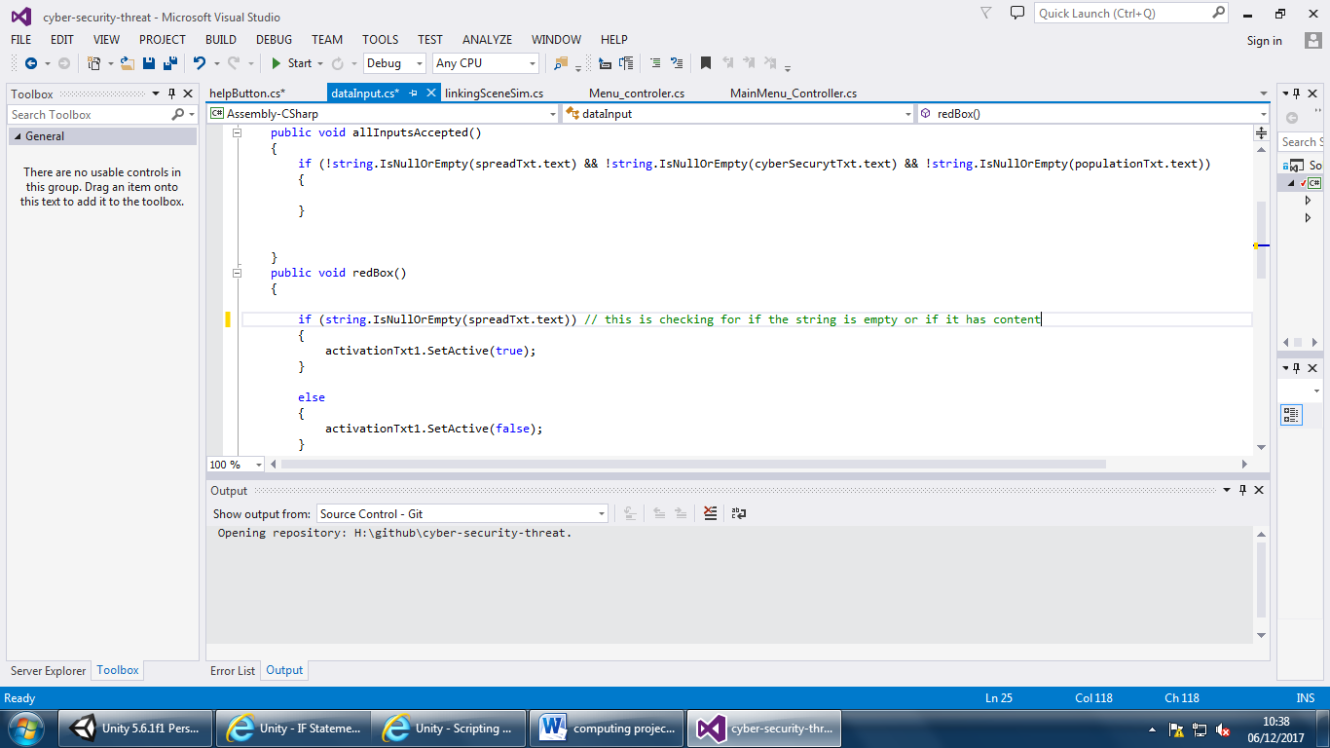

I then did this for all the different input fields

When making the default toggle for population that will make the population equal to 65.64 million. However when making this there was some issues due to me not saving the input field as an input field. Instead I was saving it as a string which meant that nothing was happening. You can see how the code works in the image bellow

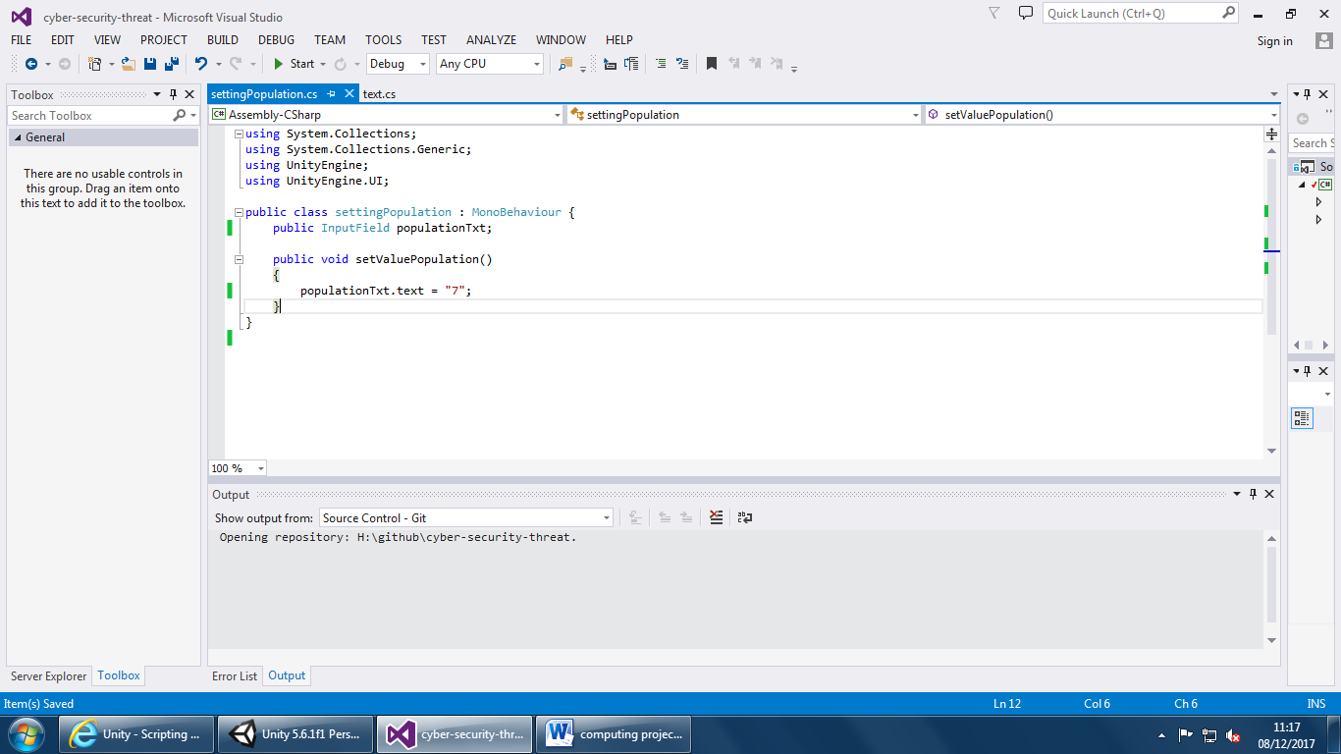

After this I then improved it by doing an if statement to check if it is empty, if it was then I would set it to the UK population but if it wasn’t then I would set it to nothing. You can see the finished code here

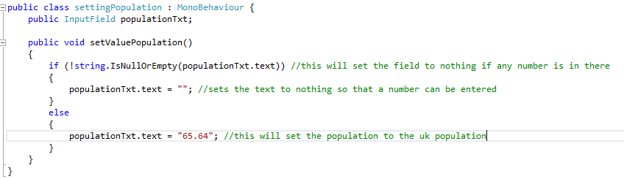

You can see it all work in this video

When doing the testing for the game so far I realised there was an issue with the anchors, when you changed the resolution to 4k all the game objects will shrink and become tiny. This meant that the game was unusable so I had to go back and add anchors to them this involved setting relative coordinates to where the object should be, this means that when the simulation was put onto a 4k monitor the game would stay the same size. During this process the format changed a bit to now the game looks like this 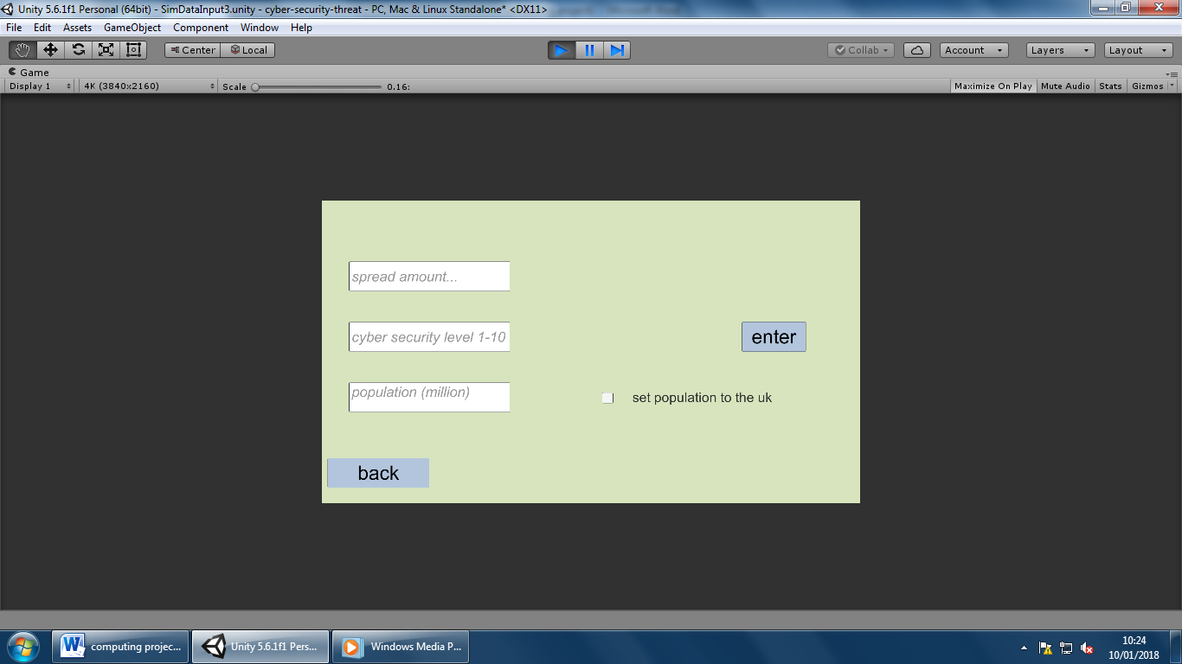

## Variable table

## Testing

## Beta testing

## Evaluation

|  |  |  |  |  |
| --- | --- | --- | --- | --- |
| Variable no. | Variable name | Type | Test data | Validation |
| 1 | mainContentAnim | Animator | n/a | n/a |
| 2 | MenuAnim | Animator | n/a | n/a |
| 3 | SpreadTxt | Text | The first kind that I used was normal data this was just numbers in this case and I used it to test to see if the input worked. After that I then used abnormal data this included strings when trying to do this I set it so the input field would only accept numbers meaning that it wouldn’t accept string. | The validation that I used on this was so that if the field didn’t have anything entered into it, it would send an error message saying to input a number. |
| 4 | CyberSecurityTxt | Text | This, like the spreadTxt, uses very similar test data I used normal data to check to see if the program would simply work without any kind of extreme or abnormal data. After this I went onto extreme this meant that if it was above 10 then it would ask for a suitable number | The validation consists of two main aspects; the first aspect was just to check to see if the field had an input, this meant that an error message would occur if there was nothing in there. The second aspect of validation is that there is an if statement checking to see if the number is between 1-10 if it isn’t it will also show an error |
| 5 | populationTxt | Text | This is identical to the spread text however there is one difference there is a tick box next to the input field which when clicked will add the population of the UK (65.64 million). The test data for this is that the tick box will be clicked on and off (normal data) the next type of test data is abnormal data this would consist of words or letters, this is abnormal because the input field only accepts numbers. | The validation for this consists of checking to see if there is data in the box and if the data is acceptable (not letters and words). The way that I checked to see if there is data in the input field was by using the .isnullorempty command to see if it was empty. The way that I checked to see if the data is valid was by setting the content type to decimal number. This mean that the number 65.64 is acceptable unlike the other two fields because they are both integer numbers (not decimals) |
|  |  |  |  |  |